STUDENT ACTIVITY GUIDE
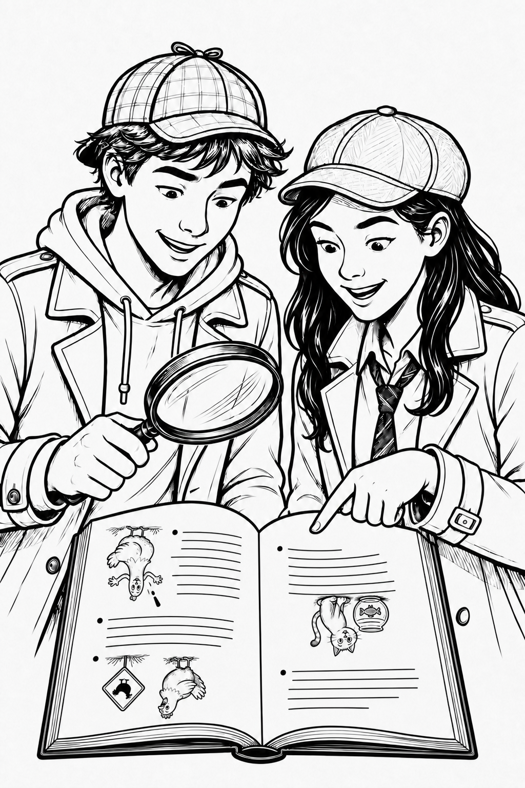
JOKE BOOK
READING ADVENTURE
──────── ◆ ────────
A Detective's Guide to
Reading Between the Laughs
Student Activity Guide - Volume 1

FOR GRADES 3 THROUGH HIGH SCHOOL
Observe clues • Think carefully • Solve the joke

JOKE BOOK READING ADVENTURE
Table of Contents
A Detective's Guide to Reading Between the Laughs
PAGE | ACTIVITY | READING SKILL | CODE
1 | Cover | — | —
2 | Table of Contents | Overview | —
3 | Welcome to Your Joke Book Adventure | Introduction | JBRA-S01
4 | Predict the Punchline | Prediction | JBRA-S02
5 | Find the Hidden Clue | Looking for clues | JBRA-S03
6 | Words with Two Meanings (Wordplay) | Wordplay | JBRA-S04
7 | Background Knowledge | Prior knowledge | JBRA-S05
8 | Visual Clues | Visual literacy | JBRA-S06
9 | Match the Joke to the Book | Theme & categorizing | JBRA-S07
10 | Which Joke Doesn't Belong? | Compare & categorize | JBRA-S08
11 | Picture It! | Visualization | JBRA-S09
12 | Solve the Joke! | Strategies together | JBRA-S10
13 | Keep Reading! | Reflection & next steps | —

YOUR READING ADVENTURE Check off each activity as you complete it.
☐ JBRA-S01 Welcome to Your Joke Book Adventure | ☐ JBRA-S06 Visual Clues
☐ JBRA-S02 Predict the Punchline | ☐ JBRA-S07 Match the Joke to the Book
☐ JBRA-S03 Find the Hidden Clue | ☐ JBRA-S08 Which Joke Doesn't Belong?
☐ JBRA-S04 Words with Two Meanings | ☐ JBRA-S09 Picture It!
☐ JBRA-S05 Background Knowledge | ☐ JBRA-S10 Solve the Joke!

Every activity makes you a stronger Joke Detective—and an even better reader!

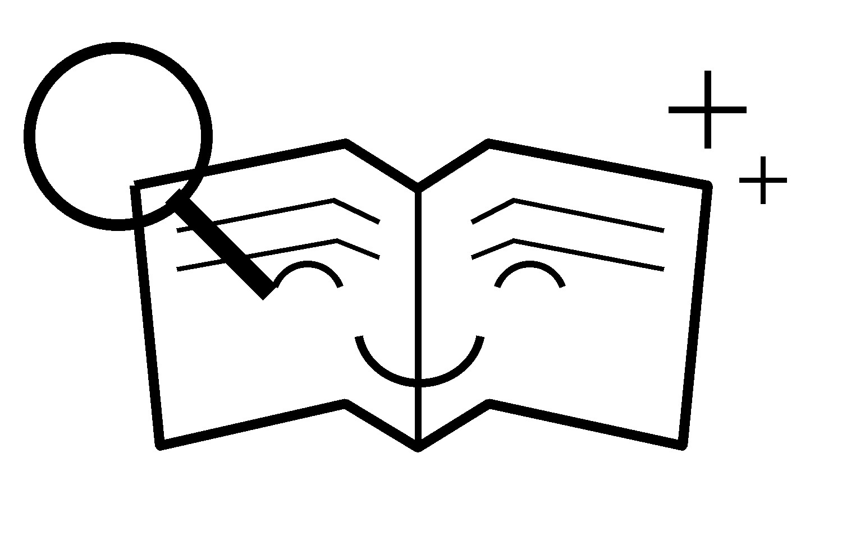
Student Introduction
ACTIVITY CODE JBRA-S01
WELCOME TO YOUR
Joke Book Adventure!
READ | PREDICT | DISCOVER | LAUGH
Why Read Joke Books?
Some people say that a joke is the ultimate short story.
Think about it. Every joke has a beginning, a middle, and an ending. It introduces characters or situations, builds your curiosity, and finishes with a surprise. That’s one reason joke books are so much fun to read—and why they’re a great way to become a stronger reader.
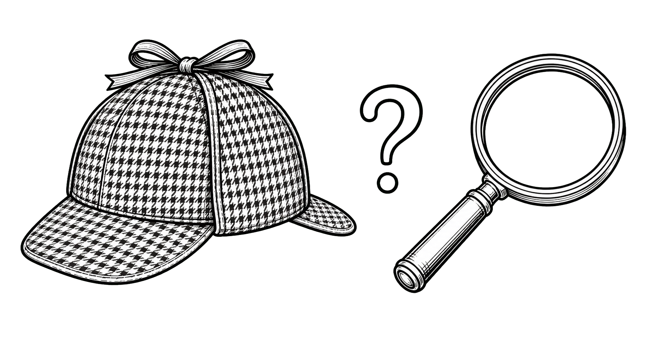

Become a Joke Detective
Every joke is like a tiny puzzle waiting to be solved.
The setup gives you clues. The punchline reveals the surprise. Sometimes you’ll figure it out before you get there. Other times the joke will catch you completely off guard!
Great joke readers do more than simply read the words. They notice funny details, notice the illustrations, think about words with more than one meaning, and use what they already know about the world to understand why a joke is funny. The more jokes you read, the easier it becomes to spot these clues—and the more fun you’ll have discovering them!
That’s what this Joke Book Adventure Guide is all about!
As you work through these activities, you’ll become a Joke Detective, searching for hidden clues, making predictions, spotting clever wordplay, drawing cartoons, creating your own jokes, and sharing laughs with friends and family.

Before You Begin
As you read your favorite joke book—or one your teacher recommends—remember these four tips:
1 Have fun!  Great joke readers know that laughter is the best part of every joke book. | 2 Look for clues.  Every setup gives hints about the punchline.
3 Think before you peek.  Can you guess the ending before you read it? | 4 Share the laughs.  Jokes are even more fun when you tell them to someone else.
Ready? Let’s begin your Joke Book Adventure!
A TINY SETUP | A SURPRISING PUNCHLINE | A BIG LAUGH

Joke Detective Activity Sheet JBRA-S02  Predict the Punchline  Name: _____________________________ Date: _________ Class/Period: ____ | READING SKILL  PREDICTION
WARM-UP
Good readers don't just read - they predict! When you read a story, you try to guess what will happen next. When you read a joke, you try to guess the punchline before you peek! Let's see how good a Joke Detective you are.
JOKE DETECTIVE CHALLENGE
Read each joke setup. Don't look at the punchline yet! Write your own funny ending first. Then uncover the real punchline and compare it with yours.
JOKE 1
Setup: Why did the coffee taste like mud?
My Punchline:
____________________________________________________________________________________________________
________________________________________________________________________________________________________
JOKE 2
Setup: What do scientists put up in their living rooms at Christmas?
My Punchline:
____________________________________________________________________________________________________
________________________________________________________________________________________________________
JOKE 3
Setup: Where do pirates go for spring break?
My Punchline:
____________________________________________________________________________________________________
________________________________________________________________________________________________________
 | BONUS CHALLENGE  Choose one of the jokes above. Can you invent another punchline that still makes sense? Write it below.  _________________________________________________  ____________________________________________________________ |  | SHARE THE LAUGH  Tell one of today's jokes to a friend or family member. Before you reveal the punchline, ask them to predict it.  Did they come up with a funny answer?  ☐ Yes! ☐ Sort of. ☐ Not even close!
 | COVER THIS BOX BEFORE YOU BEGIN. • ACTUAL PUNCHLINES
 | JOKE 1  It was just ground this morning.  ☐ Close ☐ Different ☐ Funnier | JOKE 2  A chemis-tree.  ☐ Close ☐ Different ☐ Funnier |  | JOKE 3  Arrr-gentina!  ☐ Close ☐ Different ☐ Funnier
 | RALPH’S READING TIP: Great readers make predictions all the time. The more clues you notice, the better your predictions become – even when you’re reading joke books!

JOKE DETECTIVE ACTIVITY SHEET JBRA-S03  Find the Hidden Clue  Name: _________________________________ Date: _________ Class/Period: ____ | READING SKILL  LOOKING FOR CLUES
WARM-UP
Good readers are always looking for clues. Authors hide clues in stories, and joke writers hide clues in jokes. Sometimes one little word – or even a picture – helps you understand what comes next. Today you’ll become a Clue Detective!
JOKE DETECTIVE CHALLENGE
Read each joke. Circle the word or words that give you the biggest clue to the punchline. Hint: Sometimes the illustration gives you a clue, too!
Joke 1 What do you call a number that can’t stay in one place?  A roamin’ numeral. | 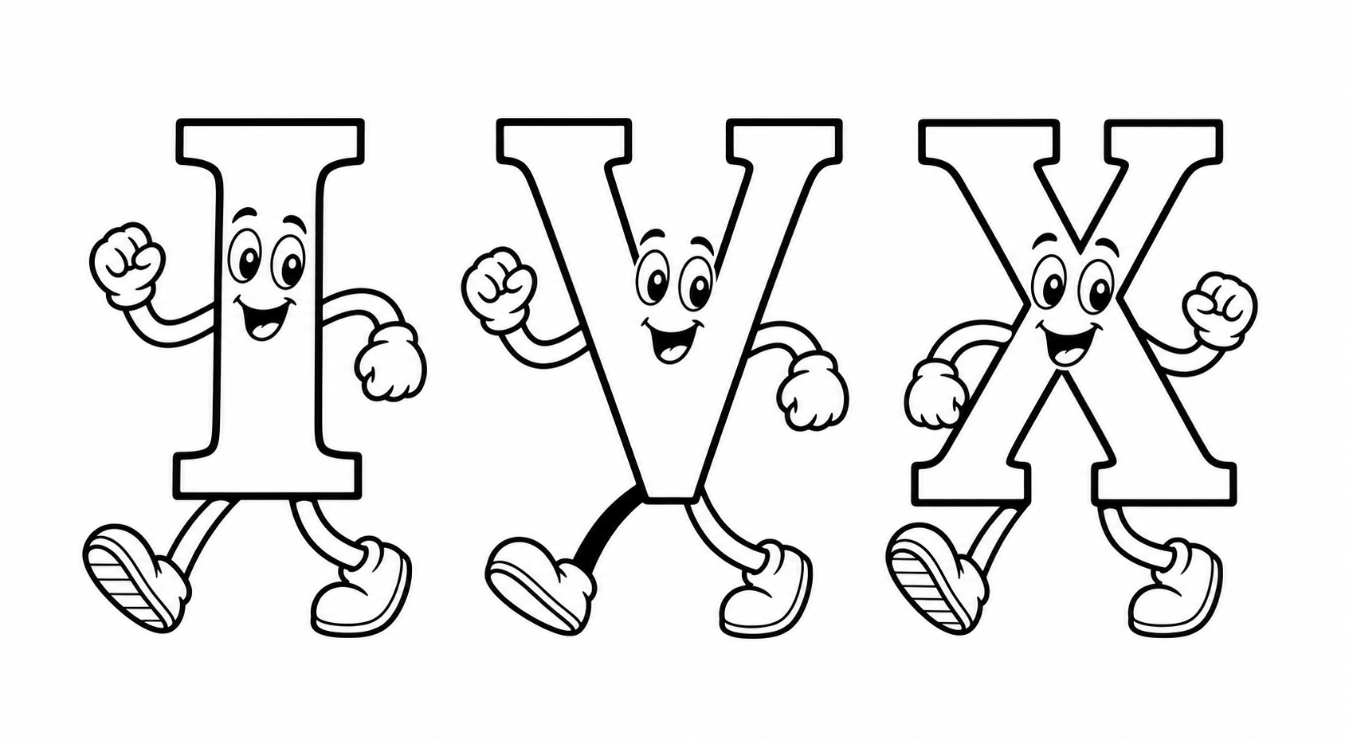
What clue helped you?

Joke 2 Where do ghosts like to travel?  Boo-dapest. | 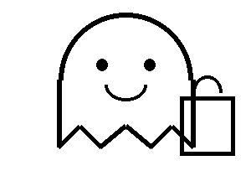
What clue helped you?

Joke 3 How often do scientists look at the table of elements?  Periodically. | 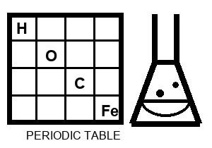
What clue helped you?

Joke 4 Why do witches stay at hotels on vacation?  So they can order broom service. | 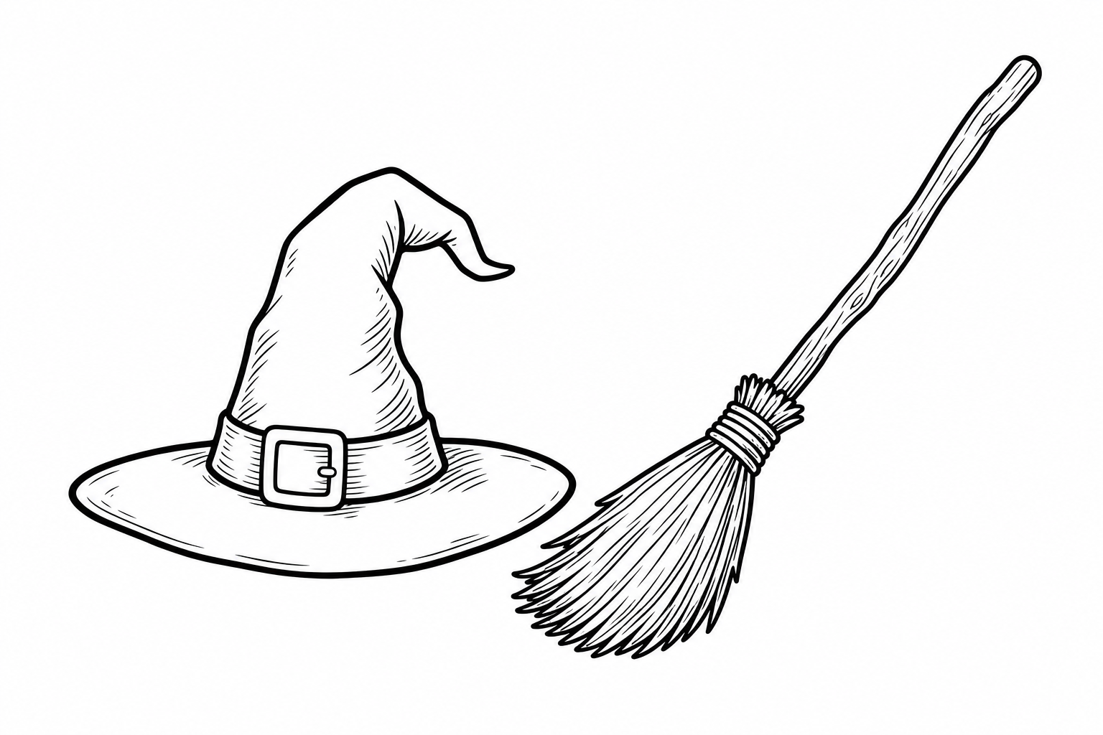
What clue helped you?

CONNECTING TO OTHER READING
Good readers look for clues everywhere, not just in joke books. The next time you read a story, chapter book, or magazine, spot a clue that helps you predict what might happen next. What is an example of a clue you could find in comic books, textbooks, or graphic novels?

BONUS CHALLENGE
Remember a joke you’ve heard, find one in a joke book, or ask someone to tell you one. Write it below, then circle or underline the clue (or clues) that help make it funny. If there is no obvious clue, draw a small illustration that gives readers a hint.

RALPH’S READING TIP The best readers notice clues before they reach the ending. The best joke readers do exactly the same thing!

JOKE DETECTIVE ACTIVITY SHEET JBRA-S04  Words with Two Meanings | READING SKILL  Wordplay

Name: _____________________________________________ Date: _____________________ Class/Period: ____________________
WARM-UP
Joke writers love to play with words! Sometimes they use a word with more than one meaning. Other times they change a spelling or phrase to create a funny new meaning. This is called wordplay. A usual choo-choo train becomes a chew-chew train when it likes to eat!
JOKE DETECTIVE CHALLENGE
Read each joke. Circle the word or words with a different spelling or meaning than you expect. Then explain the two meanings or how the joke writer changed the words.
Joke 1 What do you call a train that eats too much?  A chew-chew train. | 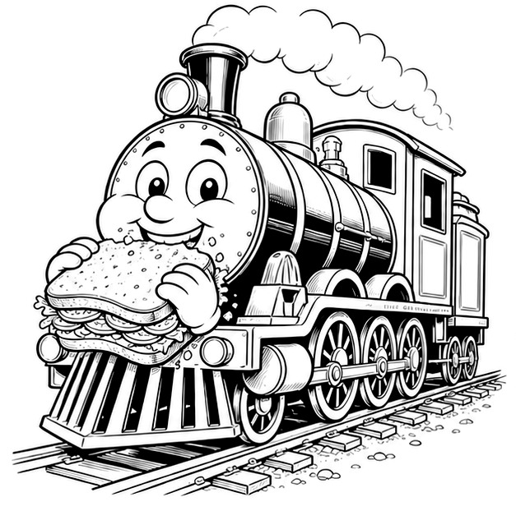

How did the joke writer change the words?

Joke 2 What do you call a crazy train?  A loco motive. | 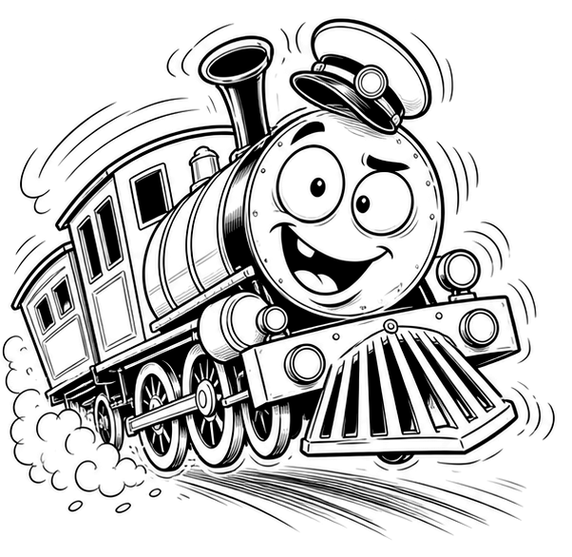

How is this different from the word locomotive?

Joke 3 What type of luggage do monsters take on vacation?  Scarey-on. | 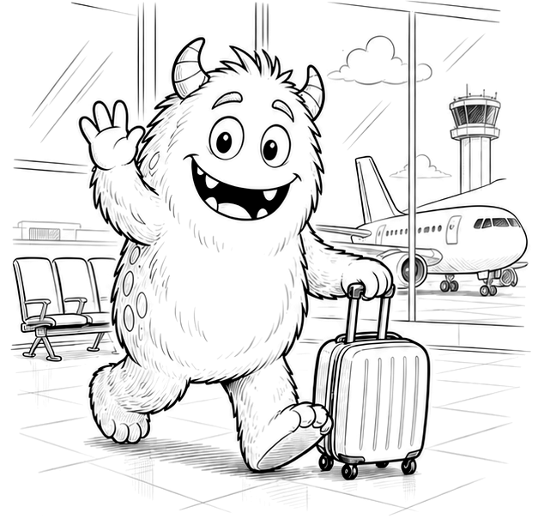

How did the joke writer change the word?

Joke 4 What do you call a biologist’s self-portrait?  A cell-fie. | 

How is this different from the word selfie?

CONNECTING TO OTHER READING
Joke writers aren’t the only authors who enjoy wordplay. The Amelia Bedelia books use funny misunderstandings, and poems by Shel Silverstein and Jack Prelutsky surprise readers with playful sounds and unexpected meanings. Watch for wordplay as you read!
BONUS CHALLENGE
Think of a joke, find one in a joke book, or ask someone to tell you one. Write it below. Circle the words that create the wordplay. If it does not use wordplay, add a small illustration that helps tell the joke.
RALPH’S READING TIP: Great readers notice when authors play with words. The more wordplay you discover, the more jokes - and books - you'll understand and enjoy!

JOKE DETECTIVE ACTIVITY SHEET JBRA-S05  Background Knowledge | READING SKILL  Using Prior Knowledge

Name: ___________________________________________________ Date: _____________________ Class/Period: ____________________
WARM-UP
Have you heard a joke that someone else understood, but you didn't? Good readers use background knowledge - facts and experiences you already have - to understand reading and jokes. The more you learn, the more jokes you'll understand!
JOKE DETECTIVE CHALLENGE
Read each joke. Then explain: What did you need to know before the joke made sense?
Joke 1 How can you tell the difference between an alligator and a crocodile?  It all depends on whether you'll see it later or in a while. | 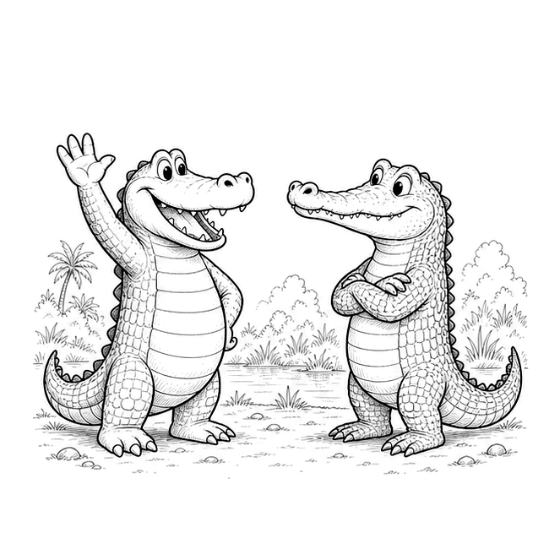

Background knowledge clue:

Joke 2 What does an Easter Bunny get for making a basket?  Two points, just like everyone else. | 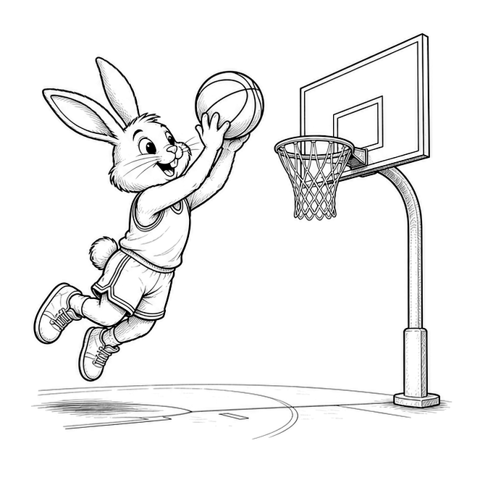

Background knowledge clue:

Joke 3 How much did Santa pay for his sleigh?  Nothing. It was on the house! | 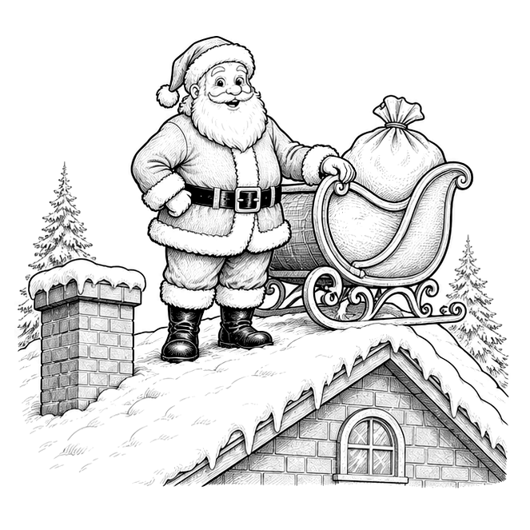

Background knowledge clue:

Joke 4 What would you get if you crossed Quasimodo with an Irish football player?  The Halfback of Notre Dame! | 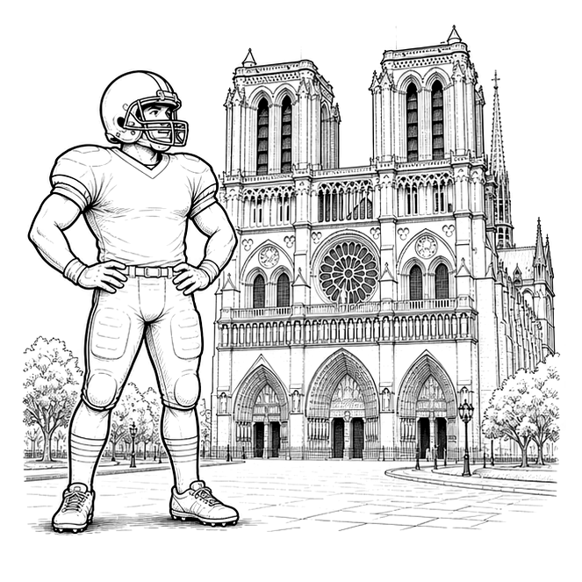

Background knowledge clue:

CONNECTING TO OTHER READING
Background knowledge helps with all kinds of books. Stories such as Charlotte's Web, The Lion, the Witch and the Wardrobe, and Harry Potter are easier when you know about farms, myths, animals, friendship, or magic. Every book builds knowledge for the next one!
BONUS CHALLENGE
Find, remember, or ask someone for a joke. Write it below. Then add one thing a reader needs to know to understand why it is funny.
RALPH'S READING TIP Every new book, experience, and fact builds your background knowledge. Great readers understand more jokes - and great joke readers become even better readers!

JOKE DETECTIVE ACTIVITY SHEET JBRA-S06  Visual Clues | READING SKILL  Visual Literacy

Name: ____________________________________________________________________________ Date: __________________________________ Class/Period: ____________________
WARM-UP
Pictures do more than make books look nice. Illustrations can reveal characters, setting, vocabulary, actions, mood, and even a joke's hidden clue. Today, become a Visual Clue Detective!
JOKE DETECTIVE CHALLENGE
Look at each picture before reading the punchline. Then answer the question below.
Joke 1 What kind of plants do ghosts like to grow?  Bam-BOO! | 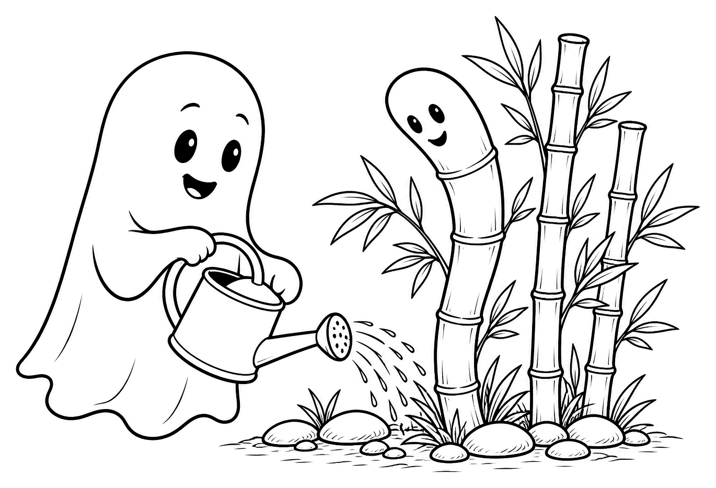

How did the illustration help you understand the joke?
________________________________________________________________________________________________________________________________________
Joke 2 How did the soggy Easter Bunny dry himself?  With a hare dryer. | 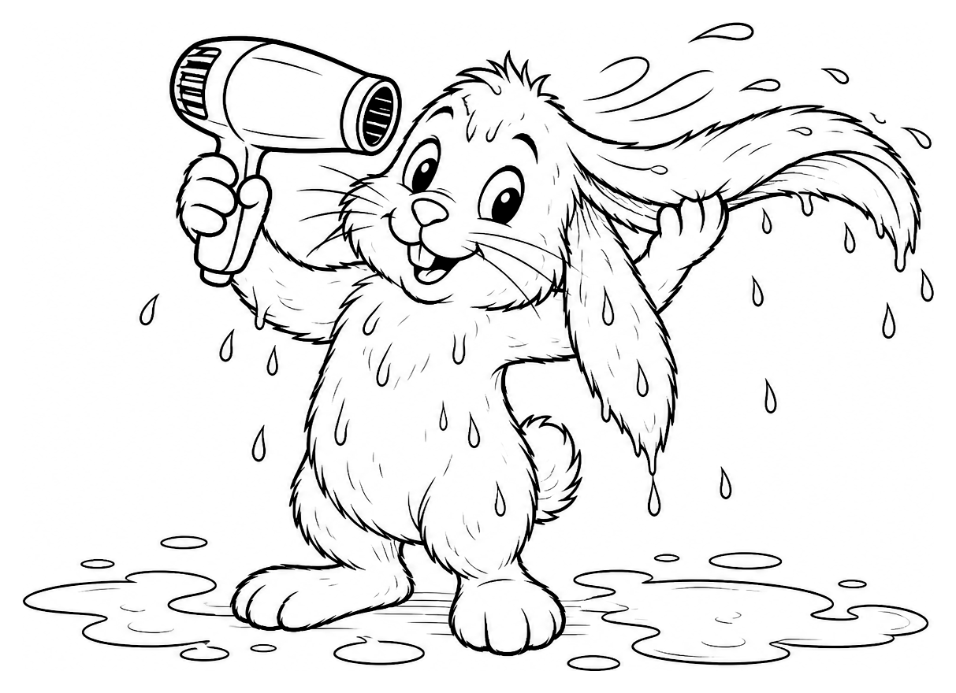

What clue did the illustration give you?

________________________________________________________________________________________________________________________________________
Joke 3 Why did the ghost mother always know when her children were fibbing?  She could see right through them. | 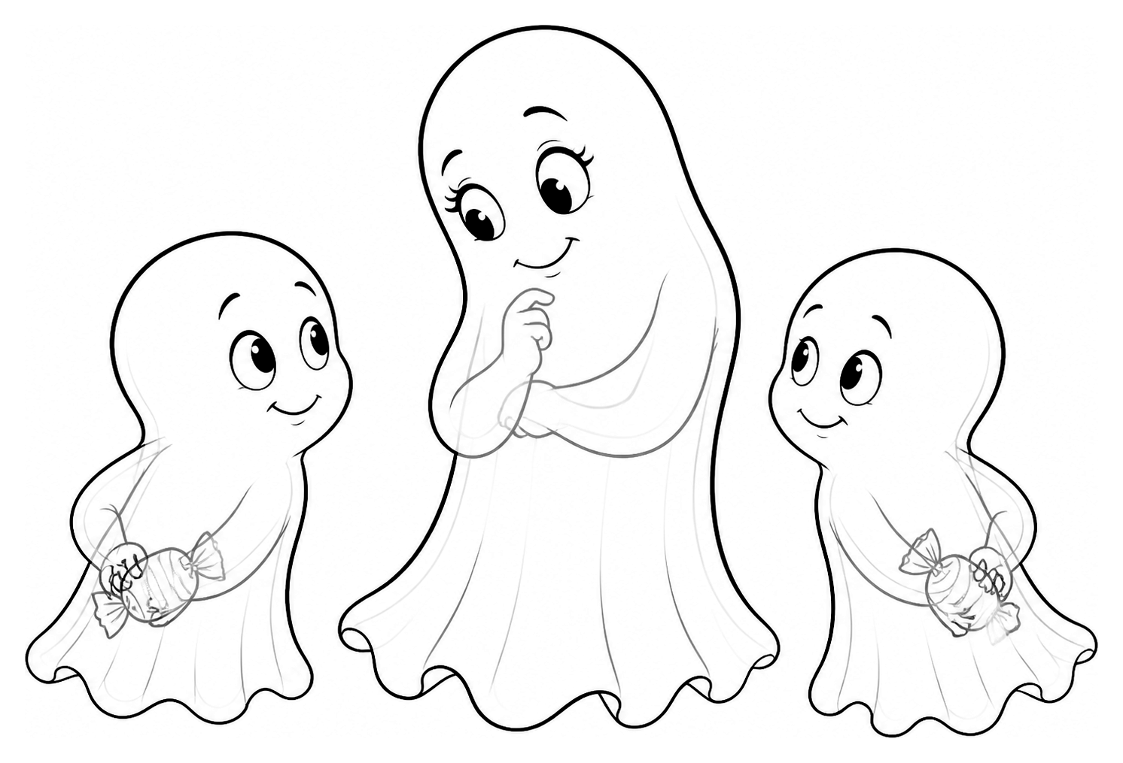

Which part of the illustration helped you understand the joke best?

________________________________________________________________________________________________________________________________________
Joke 4 What do you call a jack-o'-lantern after it eats too much Halloween candy?  A plumpkin. | 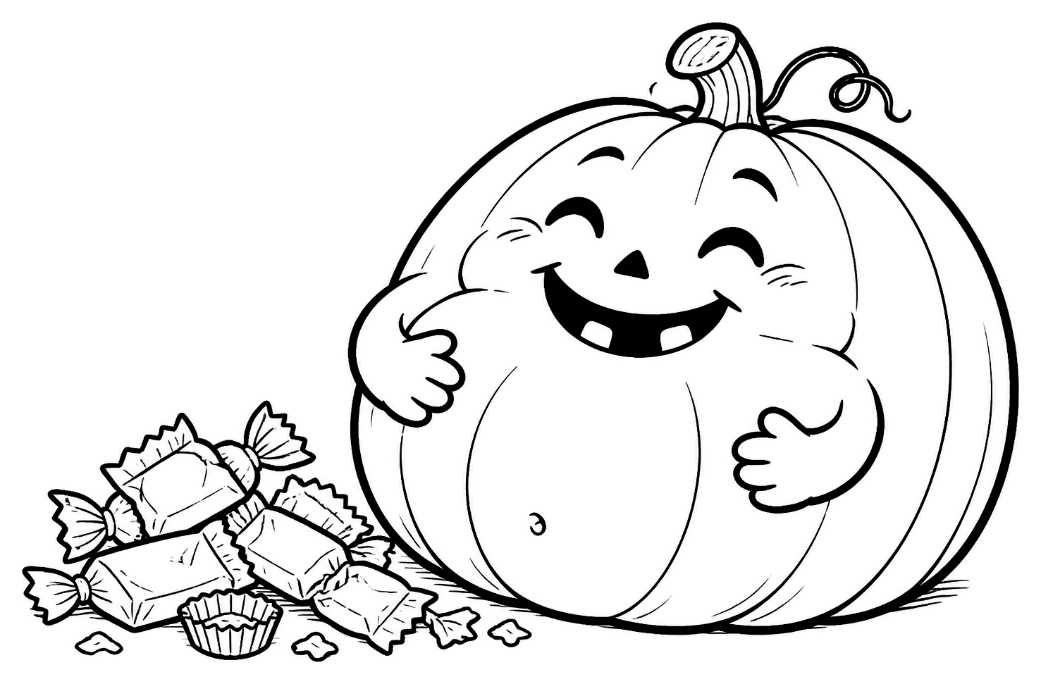

Would the joke still make sense without the illustration? Why or why not?
________________________________________________________________________________________________________________________________________
CONNECTING TO OTHER READING
Illustrations support many kinds of reading - picture books, graphic novels, comics, and textbooks. They often give clues about characters, setting, vocabulary, mood, and important events. Ask: What clues is the illustrator giving me?
BONUS CHALLENGE
Think of a favorite joke. Draw a picture that helps a reader understand it - but don't give away the punchline completely!
RALPH'S READING TIP Pictures are part of the story. Great readers use both words and illustrations to discover clues and understand what they read.

JOKE DETECTIVE ACTIVITY SHEET JBRA-S07  Match the Joke to the Book | READING SKILL  Theme & Categorizing

Name: ____________________________________________________________________________ Date: __________________________________ Class/Period: ____________________
WARM-UP
Most joke books have a theme. Good readers notice what a book is mostly about because it helps them know what to expect. Today, become a Theme Detective!
JOKE DETECTIVE CHALLENGE
Read each joke. Write the letter of the Ralph Lane joke book it most likely came from.
A Birthday B Christmas C Valentine's Day D Sports E Travel
_____ Where do cows go on vacation?  Moo York. | 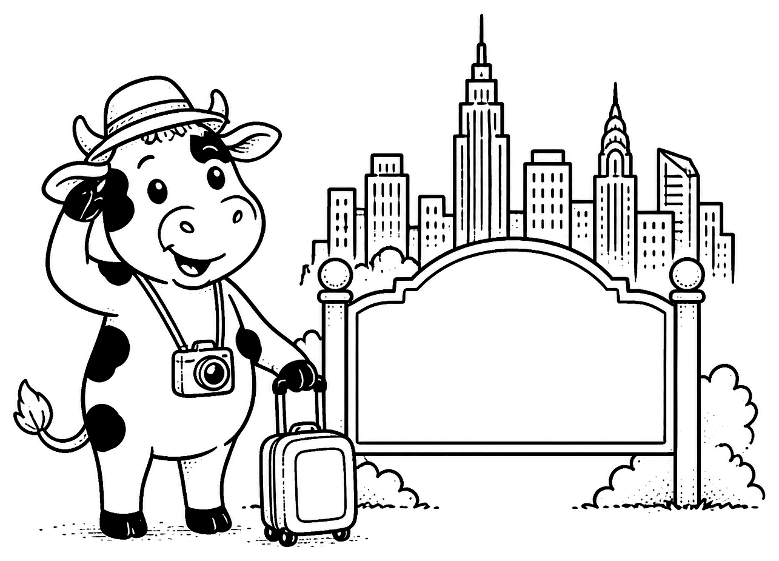

_____ What do you call two birds in love?  Tweethearts. | 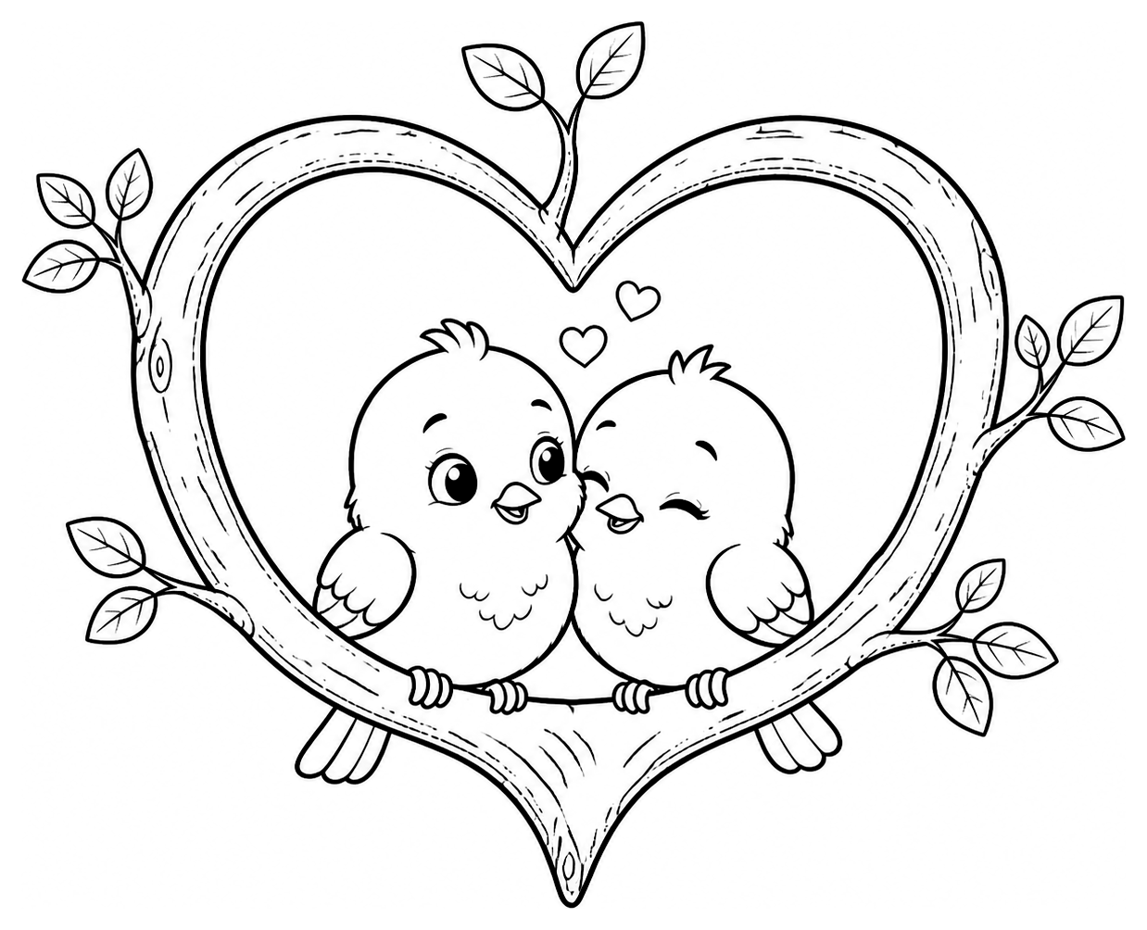

_____ What do you learn at Santa's Helpers School?  The elf-a-bet. | 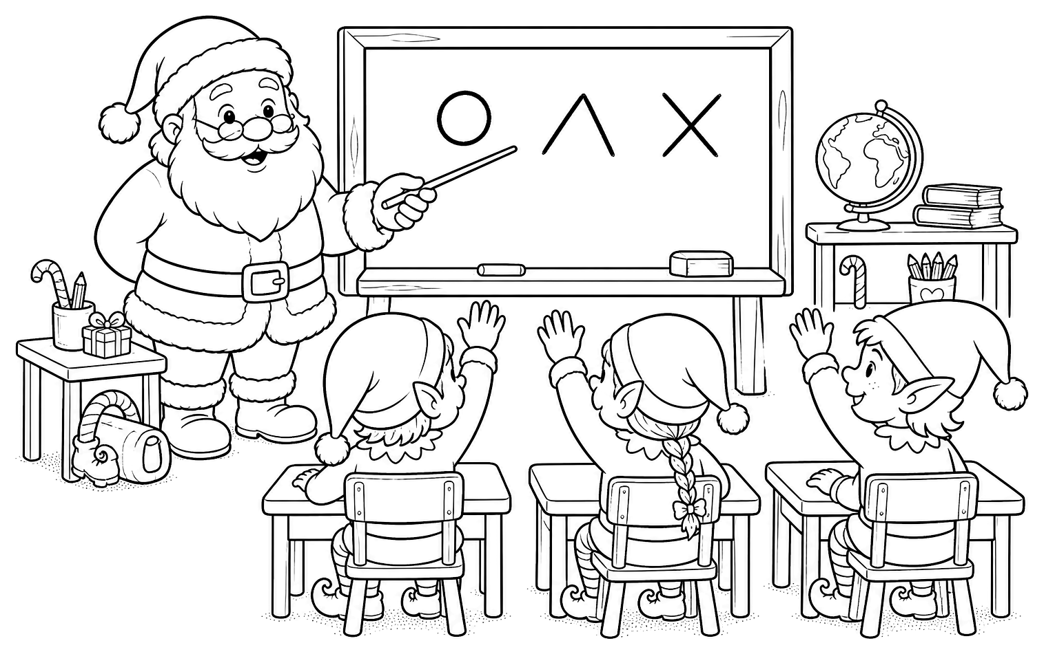

_____ Why isn't Cinderella good at soccer?  Because her coach is a pumpkin and she keeps running away from the ball. | 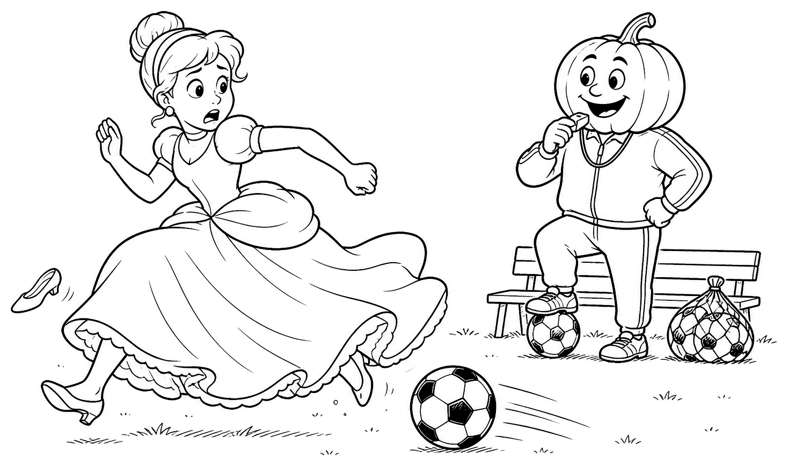

_____ What do you say to a kangaroo on its birthday?  Hoppy Birthday! | 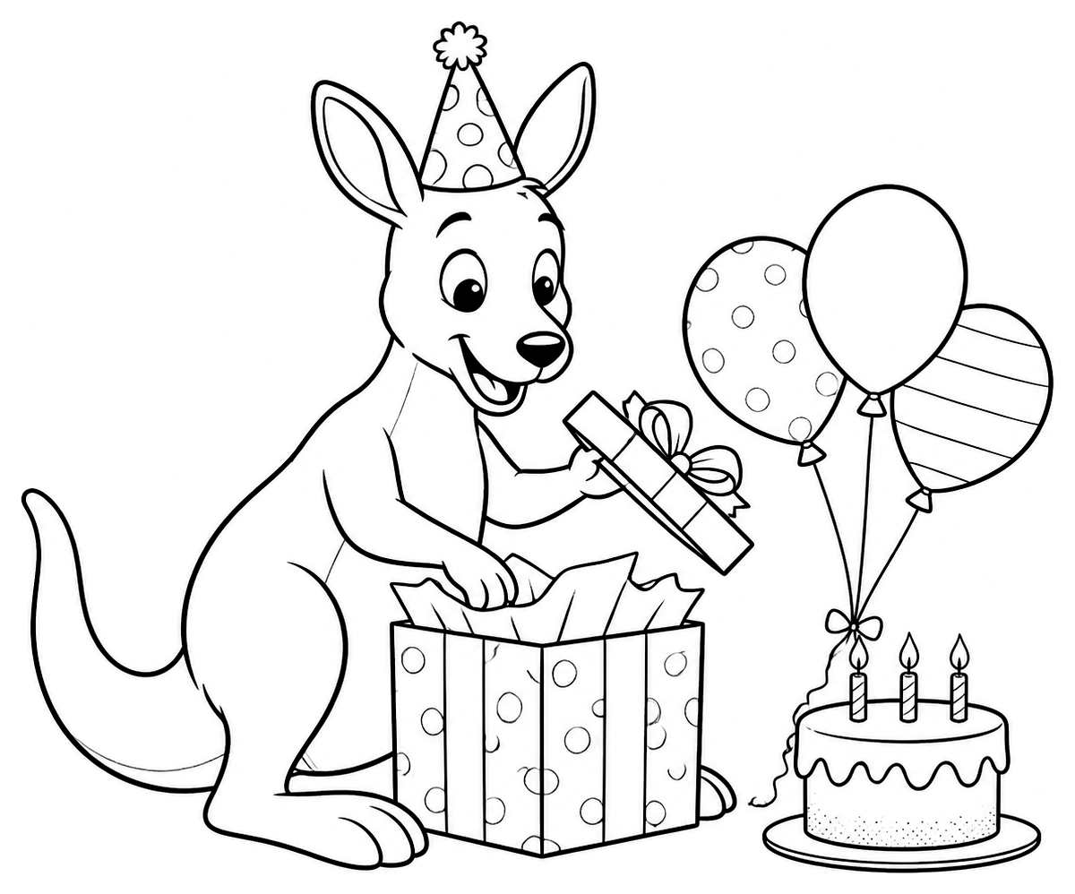

CONNECTING TO OTHER READING
Many books and other texts focus on one main topic or idea. Recognizing the theme gives you clues about what you may read, learn, or discover next. Ask: What is this mostly about?
BONUS CHALLENGE
If you could create your own themed joke book, what would it be about? Write your theme and one joke that belongs in it.
My joke book theme:
My joke:
RALPH'S READING TIP: Great readers notice themes. Knowing what a book is mostly about helps you understand new words, make predictions, and enjoy reading even more!

JOKE DETECTIVE ACTIVITY SHEET JBRA-S08  Which Joke Doesn't Belong? | READING SKILL  Comparing & Categorizing

Name: __________________________________________________ Date: ____________________ Class or Period: ______________
WARM-UP
Good readers compare ideas and sort them into categories. In each group, three jokes belong together and one is different. Circle the joke that does not belong, then explain your thinking. More than one answer may work if you support it!
JOKE DETECTIVE CHALLENGE
Read each group. Circle one letter in each group and explain why it does not belong. Be prepared to explain your answer.
Which joke doesn’t belong? Why? | Which joke doesn’t belong? Why?
  GROUP 1
  - Where do pirates go on vacation?  Arrr-gentina. | 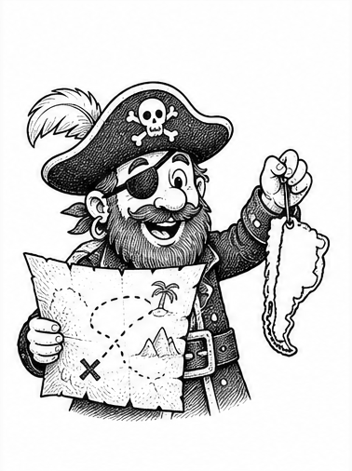
  B. What washes up on very small beaches?  Microwaves. | 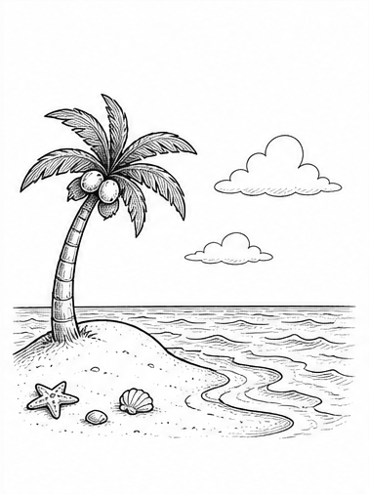
  C. What is the worst vegetable to bring on a boat?  A leek. | 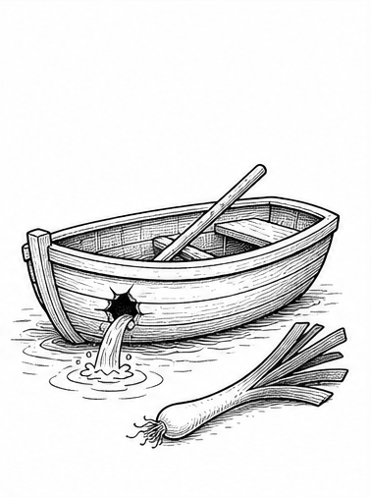
  D. Why do skunks celebrate Valentine’s Day?  Because they’re very scent-imental. | 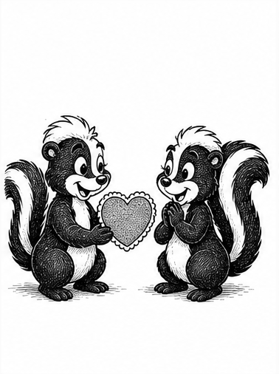
  GROUP 2
  - Why do chickens stay in shape?  Eggsercise. | 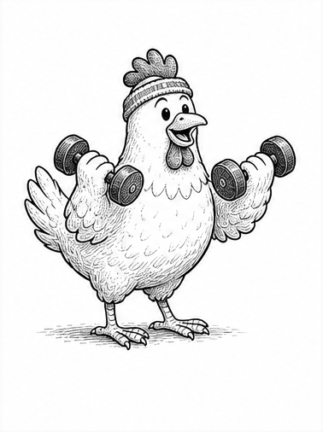
  B. What do you call a mischievous egg?  A practical yolker. | 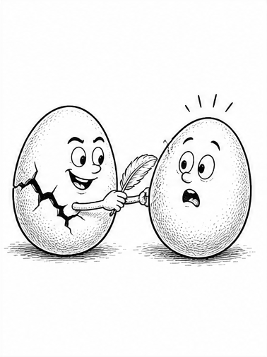
  C. Where do chickens work?  At eggplants. | 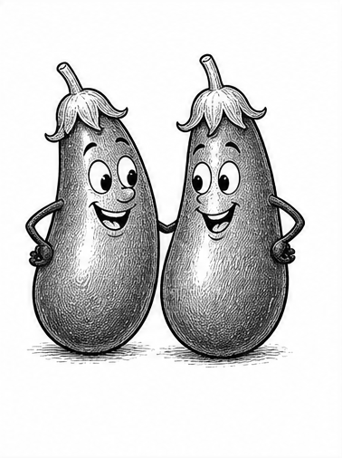
  D. What do witches ask for at a hotel?  Broom service. | 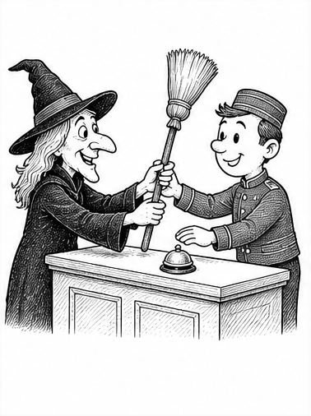
BONUS CHALLENGE
Choose one theme for a joke book. Circle it. Then list people, places, objects, or ideas that belong in that book.
◯ HALLOWEEN | ◯ SPORTS | ◯ SCIENCE
Details that belong in my themed joke book:

RALPH’S READING TIP: Strong readers compare details, notice patterns, and explain how their evidence supports a category.

JOKE DETECTIVE ACTIVITY SHEET JBRA-S09  Picture It! | READING SKILL  Visualization

Name: ___________________________________________________ Date: _____________________ Class/Period: ____________________
WARM-UP
Great readers make pictures—or even movies—in their minds. Read each joke, pause to picture the funniest scene, and then draw what you imagined. Your mental pictures can help you understand and remember what you read.
JOKE DETECTIVE CHALLENGE
Read each joke carefully. Picture the scene in your mind before you draw it. This time, you are the illustrator!
1. Why did the librarian get kicked off the plane?  Because it was overbooked.  ✎ Draw what you pictured in your mind. | 2. How do you make a ship feel better?  Give it some vitamin sea.  ✎ Draw what you pictured in your mind.
3. What do you call a train that goes deaf?  It had an engine-ear infection.  ✎ Draw what you pictured in your mind. | 4. What do you call a female snowman?  A snow-ma’am.  ✎ Draw what you pictured in your mind.
BONUS CHALLENGE
Good readers use visualization with many kinds of books—not just joke books. How could making pictures in your mind while reading science, social studies, math, short stories, chapter books, or other books help you understand and remember what you read?
RALPH'S READING TIP: When you create a clear picture in your mind, new ideas are easier to understand, connect, and remember.

JOKE DETECTIVE ACTIVITY SHEET JBRA-S10  Solve the Joke! |  | READING SKILL  Using Everything  You've Learned
Name:_____________________________ | Date:______________________ | Class/Period: ________________
WARM-UP
Congratulations! You've practiced many skills good readers use every day. As you solve each joke, think about background knowledge, wordplay, visualization, theme, predicting, and clues. Decide which strategy helped you most.
MASTER JOKE DETECTIVE CHALLENGE
Read each joke. Write the letter of the strategy that helped you understand it most, then explain why.
A Background Knowledge | B Wordplay | C Visualization | D Theme
1. What airline do ghosts fly?  Boonited Scarelines.  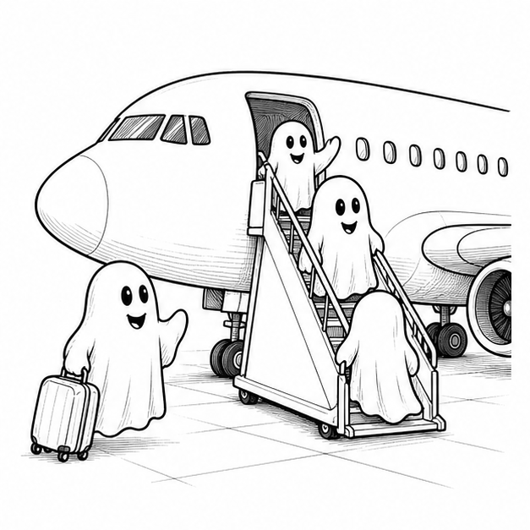  Strategy letter: ____ Why?  ________________________________________________________ |  | 2. When Oxygen and Magnesium started dating, I was all like…  “OMg!”  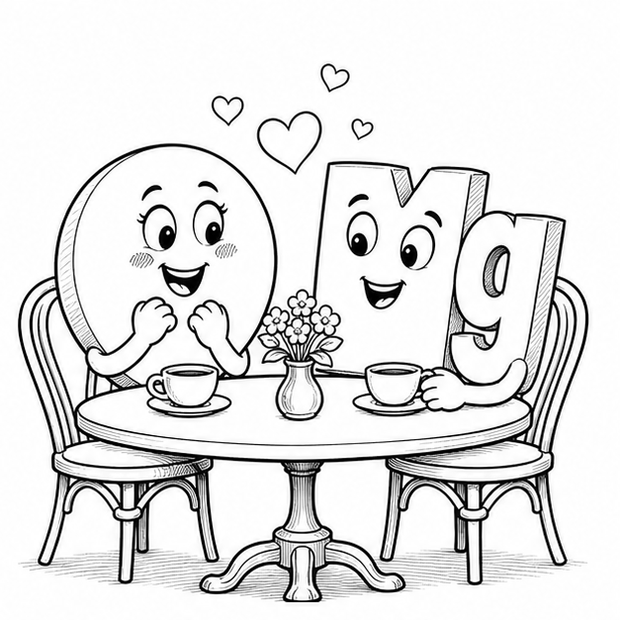  Strategy letter: ____ Why?  _______________________________________________________
3. What did one canoe say to the other?  Are you up for a little row-mance?  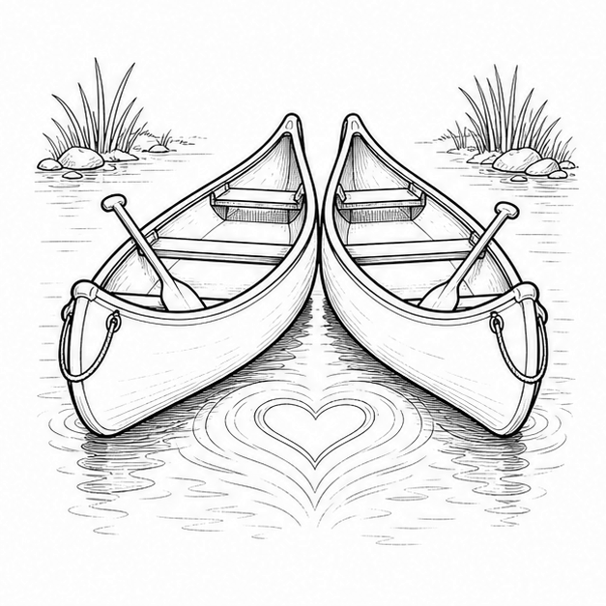  Strategy letter: ____ Why?  ________________________________________________________ |  | 4. What's the Easter Bunny's favorite story?  A Cotton Tale.  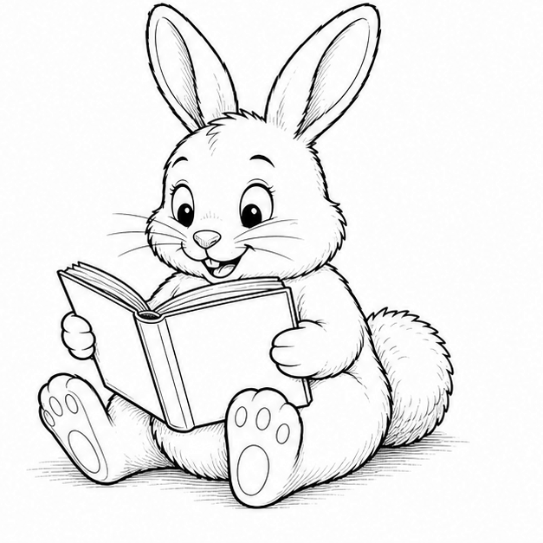  Strategy letter: ____ Why?  ________________________________________________________
CONNECTING TO OTHER READING
Think about a chapter book, short story, science lesson, or social studies assignment. Did you predict, picture ideas, use background knowledge, notice clues, or figure out a word from context? Those are the same strategies you practiced with joke books.
BONUS CHALLENGE
Which reading strategy has helped you the most? Why do you think it will help you become a better reader?
____________________________________________________________________________________________________
____________________________________________________________________________________________________
____________________________________________________________________________________________________
RALPH'S READING TIP Every great reader has a toolbox full of strategies. The more tools you learn to use, the easier—and more enjoyable—reading becomes!

JOKE BOOK READING ADVENTURE  Keep Reading! | CONGRATULATIONS,  Joke Detective!
You've learned that great readers use lots of different strategies. The more you practice them, the easier it becomes to understand stories, solve jokes, and enjoy reading.
READING STRATEGIES YOU'VE PRACTICED
✓ Making predictions | ✓ Recognizing themes
✓ Looking for clues | ✓ Comparing ideas
✓ Understanding wordplay | ✓ Visualizing what you read
✓ Using background knowledge | ✓ Paying attention to illustrations
Every joke is a tiny reading adventure. Keep reading, keep thinking, and keep laughing!
CONTINUE YOUR JOKE BOOK ADVENTURE
Looking for another great joke book? Try one of these fun themed books by Ralph Lane.

 | Dad Jokes Gift Book |  | Christmas Jokes Gift Book
 | Birthday Jokes Gift Book |  | Easter Jokes Gift Book
 | Halloween Jokes Gift Book |  | Valentine's Day Gift Book
 | Math Jokes Gift Book |  | Science Jokes Gift Book
 | Sports Jokes Gift Book |  | Travel Jokes Gift Book
Which one would you like to read next?

JOKE BOOKS I'D LIKE TO READ
Write down books from the list above—or any other joke books you'd like to read.
_____________________________________________________________________________________
_____________________________________________________________________________________
_____________________________________________________________________________________
_____________________________________________________________________________________
_____________________________________________________________________________________
MY FAVORITE JOKES
Write down a favorite joke so you can remember it and share it later.

RALPH'S FINAL READING TIP The best readers never stop being curious. Keep reading, keep laughing, and keep discovering new jokes—and new books!

