TEACHER INSTRUCTIONAL GUIDE
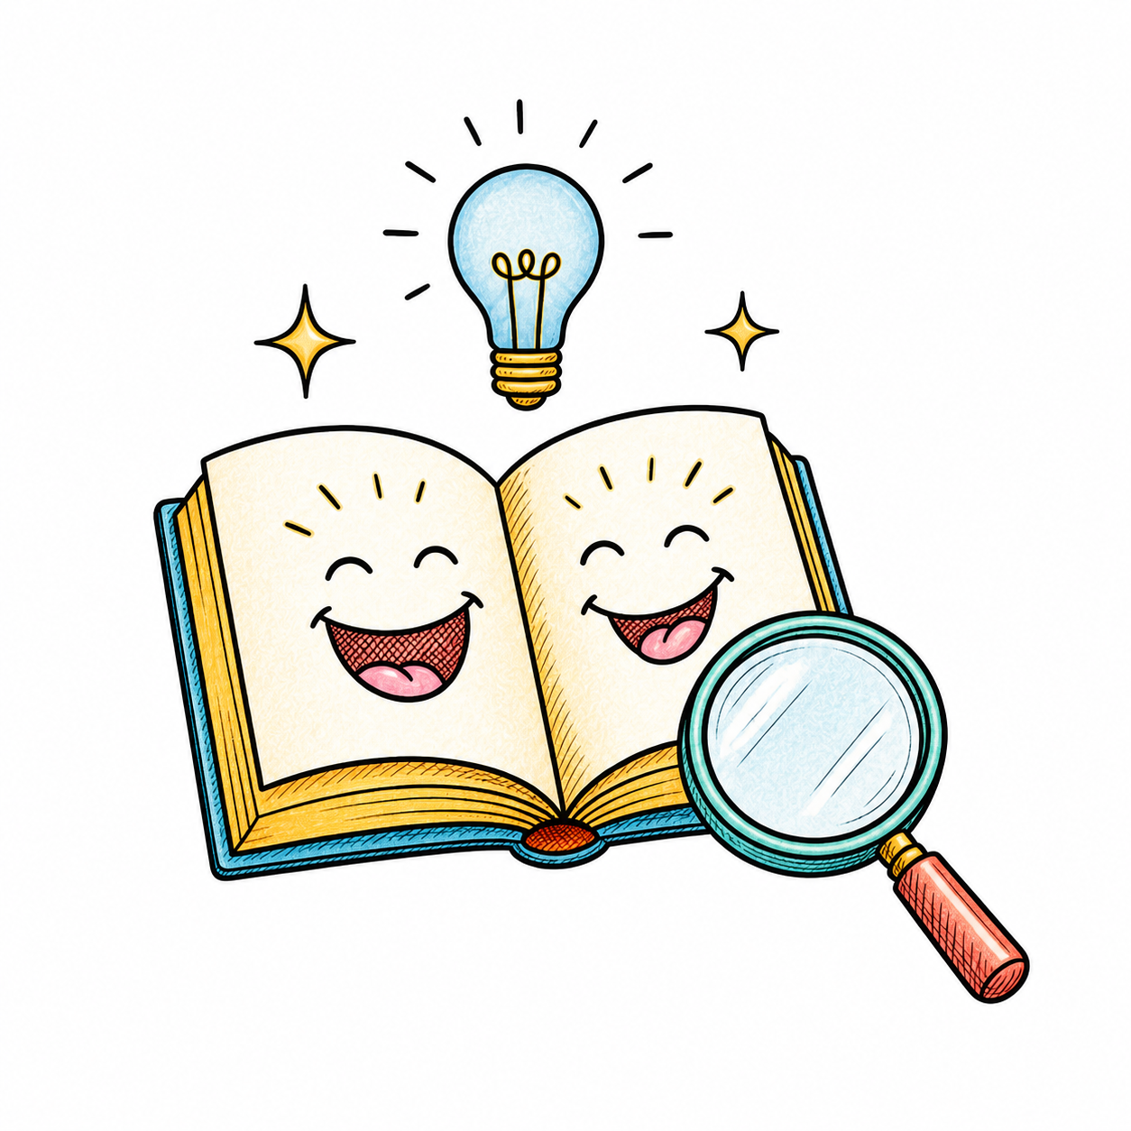
JOKE BOOK
READING ADVENTURE
──────── ◆ ────────
A Detective's Guide to
Reading Between the Laughs
Teacher Instructional Guide - Volume 1

FOR EDUCATORS • GRADES 3 THROUGH HIGH SCHOOL
Teach the clues • Guide the thinking • Share the laughter

Introduction
Welcome to Joke Book Reading Adventure: A Detective’s Guide to Reading Between the Laughs Instructional Guide!
Most students think of joke books as something they read just for fun. They’re right—but that’s only part of the story.
A joke is often called the ultimate short story. Like any good story, it has a beginning, builds toward an ending, and asks readers to think about clues before they discover the surprise. Understanding a joke requires many of the same reading strategies students use when reading fiction, nonfiction, poetry, picture books, chapter books, and even textbooks.
This guide is designed to help you turn those moments of laughter into meaningful reading experiences without taking away the fun. Each activity encourages students to think like readers while still enjoying the humor that makes joke books so appealing.
The companion Student Activity Guide includes ten engaging activities that gradually introduce important reading strategies. Each activity can be used on its own or as part of a complete sequence. Most lessons can be completed in about 10–20 minutes and work well in whole-class instruction, small groups, literacy centers, intervention, enrichment, substitute teacher plans, library lessons, summer programs, homeschooling, or at home with families.
One of the best features of this guide is its flexibility. Every activity can be completed using only the student activity sheet. However, the activities become even more meaningful when students also have opportunities to read and enjoy joke books. Illustrated joke books provide additional visual clues that support comprehension, while themed joke books—such as science, math, sports, travel, and holiday joke books—create even more opportunities to build vocabulary, background knowledge, and reading comprehension.
Throughout this Instructional Guide you’ll find:
- Teaching tips and classroom suggestions
- Learning objectives
- Discussion ideas
- Answer keys, when appropriate
- Extension activities
- Ideas for differentiating instruction
- Cross-curricular connections
- Brief explanations of why each activity works
- Recommended joke books and additional resources
Although these activities begin with jokes, the reading strategies students practice will strengthen comprehension across all kinds of reading. Our goal is simple: to help students discover that becoming a better reader and having fun can go hand in hand.
Welcome to the adventure!

Quick Reference Guide
  - Find the right student activity for the reading skill you want to reinforce.
If you want students to practice… | Use this activity | Activity Code
Making predictions | Predict the Punchline | JBRA-S02
Understanding how jokes are organized (setup and punchline) | Every Joke Has Two Parts | JBRA-S03
Recognizing wordplay and multiple meanings | Words with Two Meanings (Wordplay) | JBRA-S04
Using background knowledge to improve comprehension | Background Knowledge | JBRA-S05
Learning from illustrations and visual clues | Visual Clues | JBRA-S06
Identifying themes and categorizing ideas | Match the Joke to the Book | JBRA-S07
Comparing, sorting, and explaining thinking | Which Joke Doesn't Belong? | JBRA-S08
Creating mental images while reading | Picture It! | JBRA-S09
Applying multiple reading strategies together | Solve the Joke! | JBRA-S10

At a Glance
Plan for 10–20 minutes, depending on students’ age and ability.
As a whole-class lesson
In small groups
During literacy centers
As independent practice
With partners
As a library or media center activity
For intervention or enrichment
As a fun Friday or end-of-week reading activity
As a simple activity on substitute teacher days
During summer reading programs
At home with parents or caregivers
Most activities work well with any joke book, although themed joke books often provide additional opportunities for discussion and extension activities. Some of the activities require illustrated joke books. You will find joke book recommendations at the end of this guide.

Suggested Sequence
The activities gradually introduce increasingly sophisticated reading strategies.
1. Introduction: Welcome to Joke Book Reading
2. Predict the Punchline
3. Every Joke Has Two Parts
4. Words with Two Meanings (Wordplay)
5. Background Knowledge
6. Visual Clues
7. Match the Joke to the Book
8. Which Joke Doesn't Belong?
9. Picture It!
10. Solve the Joke!
First time? Follow the sequence. Later, use individual sheets independently to reinforce specific skills.

Finding Activities Quickly
Every student activity has a permanent code (for example, JBRA-S05). Use it to locate the matching student activity sheet, answer key, teaching suggestions, and extension ideas.
Built to grow. The codes remain consistent as additional volumes and activities are developed, making the classroom collection easy to expand over time.

General Teaching Tips
Every class is different, and every student learns in a unique way. The activities in Joke Book Reading Adventure are designed to be flexible. Feel free to adapt them to fit the age, interests, and reading abilities of your students.

Keep the Focus on Fun
The goal of these activities is not to "explain the joke." The goal is to help students discover why a joke is funny while practicing important reading skills. If students are laughing, sharing jokes, and asking questions, they're engaged in meaningful reading.

Encourage Thinking Before Explaining
When a student doesn't understand a joke, resist the temptation to explain it immediately.
Instead, ask questions such as:
- What clues do you notice? (context clues)
- Is there a word with two meanings? (wordplay)
- What do you already know that might help? (background knowledge)
- Can you picture what's happening? (mental images)
- Would the illustration help? (visual clues)
Often, students can figure out the joke themselves with a little guidance.

There Is Often More Than One Good Answer
Some activities ask students to explain their thinking or defend an answer. Encourage respectful discussion. Students may notice different clues or make different connections, and more than one answer may be reasonable if it is supported with evidence from the joke. This unit is especially well suited to partner, small group, and whole class discussions.

Build Background Knowledge Naturally
Some jokes depend on experiences or information students may not yet have. That's perfectly normal.
Treat these moments as opportunities to build vocabulary and background knowledge rather than as mistakes. As students read more books and learn more about the world, they'll understand more jokes—and become stronger readers.

Use the Illustrations
Illustrations are more than decorations. They often provide clues about characters, setting, vocabulary, mood, or the punchline.
Invite students to study the pictures before and after reading a joke. Ask how the illustration helped them understand the humor.

Choose Joke Books Thoughtfully
Although every activity can be completed without additional materials, students benefit even more when they have access to joke books.
Illustrated joke books help students notice visual clues.
Themed joke books—such as science, math, sports, travel, and holiday collections—help build vocabulary and background knowledge while making reading more enjoyable.

Make Reading Social
Students love sharing jokes.
Invite partners or small groups to read jokes aloud, discuss them, perform them, or recommend favorites to classmates. Talking about what they read strengthens comprehension while making reading a shared experience.

Celebrate Growth
Not every student will understand every joke right away—and that's okay.
Help students recognize that every joke they understand is another step toward becoming a stronger reader. Celebrate curiosity, persistence, and a willingness to keep trying.
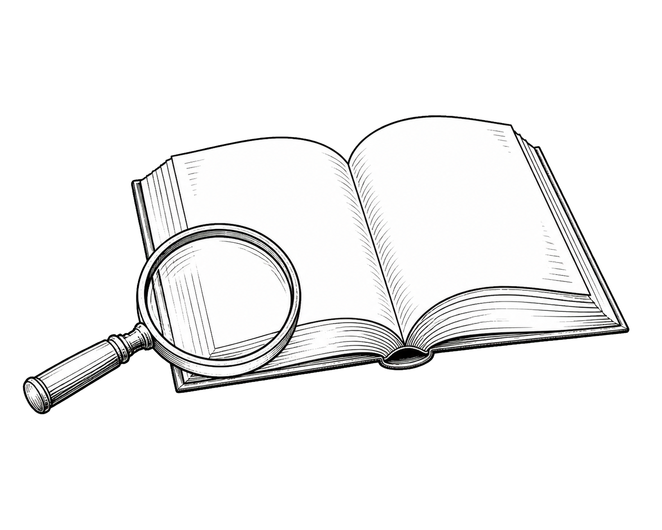 | TEACHING TIP  The best joke readers are usually the students who are willing to slow down, think about clues, and enjoy the process of figuring the joke out. Encourage students to become Joke Detectives, not just joke collectors.

INSTRUCTIONAL GUIDE
Welcome to Joke Book Reading
JBRA-T01 COMPANION STUDENT ACTIVITY JBRA-S01
 READING FOCUS
Positive reading habits • active reading strategies
 LEARNING OBJECTIVE
Students discover that understanding jokes calls on the same skills used in fiction, nonfiction, and poetry. They begin thinking like Joke Detectives who actively look for clues as they read.
 MATERIALS NEEDED
- JBRA-S01 student activity sheet and pencil
- Optional: illustrated or themed joke books
 BEFORE STUDENTS BEGIN
Ask: “What makes something funny?” Then ask: “Have you ever heard a joke you didn’t understand at first?” Explain that understanding jokes is a reading skill that grows stronger with practice.
 TEACHING TIPS
Read the introduction together or independently. Pause to consider why some jokes are hard to understand, which clues help, how jokes resemble stories, and why background knowledge matters. Keep the tone curious and light.
 WHY THIS ACTIVITY WORKS
Many students see reading and humor as separate. This activity reveals how joke readers use prediction, inference, vocabulary, background knowledge, visualization, and other strategies—often without realizing it. Making that connection helps students transfer those strategies to other reading.
 DISCUSSION QUESTIONS
- Why do some people understand a joke right away while others don’t?
- Which reading strategy might help you most?
- How can an illustration make a joke funnier?
- What kinds of joke books do you enjoy?
 EXTENSION ACTIVITIES
- Invite students to bring in a favorite joke book.
- Display several types of joke books in the classroom.
- Predict which joke-book theme will be a unit favorite.
 DIFFERENTIATE THE LESSON
Support: Read the introduction aloud and discuss it together.
Challenge: Compare reading a joke with reading a very short story.
 CROSS-CURRICULAR CONNECTIONS
Language Arts • Library • Art (illustrations) • Speaking & Listening
 RECOMMENDED JOKE BOOKS
Any illustrated joke book works well. For variety, try dad jokes or science, math, and holiday collections.
 TEACHING TIP
Keep this first lesson relaxed and enjoyable. Students should leave excited to become Joke Detectives—not feeling as though they’ve started another workbook.

JOKE BOOK READING ADVENTURE
INSTRUCTIONAL GUIDE
Predict the Punchline
JBRA-T02 COMPANION STUDENT ACTIVITY JBRA-S02
📖 READING FOCUS
Prediction
🎯 LEARNING OBJECTIVE
Students will use clues in a joke’s setup to predict a possible punchline before reading the actual ending. They will discover that good readers make predictions by thinking about context clues, vocabulary, background knowledge, and the author’s purpose rather than simply guessing.
🧰 MATERIALS NEEDED
- JBRA-S02 Student Activity Sheet and pencil
- Optional: one or more illustrated joke books
- Optional: themed joke books
🚦 BEFORE STUDENTS BEGIN
Ask: “Have you ever guessed what was going to happen next in a story or movie?” Explain that readers do this all the time. Jokes also encourage readers to predict what comes next—but the funniest punchlines are often the ones we don’t expect.
👩‍🏫 TEACHING TIPS
Encourage students to make thoughtful predictions before reading each punchline. Remind them that the goal is not to predict the exact answer; it is to notice clues and consider possibilities. Celebrate creative predictions, even when they differ from the original.
💡 WHY THIS ACTIVITY WORKS
Prediction is one of the most important comprehension strategies. Whether students are reading a joke, a mystery, a chapter book, or a science article, successful readers are constantly thinking ahead. Jokes provide immediate feedback because students instantly discover whether their predictions matched the author’s surprise ending.
💬 DISCUSSION QUESTIONS
- Which clues helped you make your prediction?
- Were any of the punchlines completely unexpected?
- Did any joke have more than one possible ending?
- Why do surprise endings often make jokes funnier?
🚀 EXTENSION ACTIVITIES
- Pause while reading a story and ask students to predict what happens next.
- Read only the setup of several new jokes and let students invent their own punchlines.
- Compare student punchlines with the author’s version and discuss why each one is funny.
🌟 DIFFERENTIATE THE LESSON
Support: Discuss the clues together before students write a prediction. Challenge: Ask students to explain which clues led to their prediction and whether classmates’ ideas would change it.
🔗 CROSS-CURRICULAR CONNECTIONS
Language Arts • Creative Writing • Speaking & Listening • Drama
📚 RECOMMENDED JOKE BOOKS
Short setup-and-punchline joke books work especially well. Themed science, math, travel, and holiday collections encourage students to use vocabulary and background knowledge.
💡 TEACHING TIP
Remind students that making an incorrect prediction is not a mistake. Every prediction gives readers another opportunity to think, adjust their ideas, and become more active readers.
🔄 BEYOND JOKE BOOKS
Encourage students to pause while reading chapter books, nonfiction, or poetry and predict what might happen next. This simple habit keeps readers actively engaged and reinforces that prediction is a transferable reading strategy they can use with any kind of text.

JOKE BOOK READING ADVENTURE
INSTRUCTIONAL GUIDE
Find the Hidden Clue
JBRA-T03 COMPANION STUDENT ACTIVITY JBRA-S03

 READING FOCUS
Using Context Clues
 LEARNING OBJECTIVE
Students will learn to look for clues hidden in words, phrases, and illustrations to help them understand a joke. They will discover that good readers are always looking for clues, whether they are reading jokes, stories, nonfiction, poetry, or informational text.
 MATERIALS NEEDED
- JBRA-S03 Student Activity Sheet and pencil
- Optional: one or more illustrated joke books
- Optional: themed joke books
 BEFORE STUDENTS BEGIN
Ask: “Have you ever solved a mystery by noticing a small clue that someone else missed?” Explain that readers do something very similar. Authors often leave clues that help readers understand what they’re reading. Today, students will practice becoming reading detectives by looking for those clues.
 TEACHING TIPS
Encourage students to slow down and look carefully before answering. Ask:
- Which word gives you the biggest clue?
- Is there another clue in the illustration?
- What makes this clue important?
- Would the joke still make sense without that clue?
Remind students that strong readers rarely guess. Instead, they combine several clues before deciding what the joke means.
 WHY THIS ACTIVITY WORKS
Many students read text without paying attention to important details. This activity teaches them to notice clues and think about how those clues work together. These same habits improve comprehension in every kind of reading, from picture books to science articles.
 DISCUSSION QUESTIONS
- Which clue helped you understand the joke first?
- Did you notice a clue that someone else missed?
- Were any clues found in the illustration instead of the words?
- Why do authors sometimes hide clues instead of giving readers the answer immediately?

 EXTENSION ACTIVITIES
- Read several new jokes together and ask students to circle or underline the most important clue in each one.
- Have students exchange papers and compare which clues each person selected.
- Read a short mystery, picture book, or nonfiction passage and ask students to identify clues that help them understand the text.
 DIFFERENTIATE THE LESSON
Support: Read each joke aloud and discuss one clue together before students work independently.
Challenge: Ask students to explain why one clue is more important than another and whether multiple clues work together to create the humor.
 CROSS-CURRICULAR CONNECTIONS
Language Arts • Science (observing details) • Social Studies (using evidence) • Fiction and Non Fiction Reading • Speaking & Listening
 RECOMMENDED JOKE BOOKS
Illustrated joke books work especially well because students can search for clues in both the words and the pictures. Themed joke books also encourage students to use clues related to science, math, travel, sports, holidays, and other familiar topics.
TEACHING TIP
When students miss a joke, avoid explaining it immediately. Instead, ask, “What clue do you think we overlooked?” That question encourages students to reread, think more carefully, and develop independence as readers.
 BEYOND JOKE BOOKS
Encourage students to become “clue hunters” whenever they read. In stories, clues help readers understand characters and predict events. In nonfiction, clues help readers determine the meaning of unfamiliar vocabulary and identify important information. In poetry, clues help readers uncover deeper meanings and appreciate the author’s word choices. The more students practice looking for clues, the more confident and successful they become with every type of reading.

JOKE BOOK READING ADVENTURE
INSTRUCTIONAL GUIDE
Notice Word Play
JBRA-T04 COMPANION STUDENT ACTIVITY JBRA-S04

READING FOCUS
Recognizing Wordplay and Multiple Meanings
LEARNING OBJECTIVE
Students will recognize that many jokes depend on words with more than one meaning or on words that sound alike but have different meanings. They will discover that noticing wordplay helps them understand humor while strengthening vocabulary, reading comprehension, and appreciation for language.
MATERIALS NEEDED
- JBRA-S04 Student Activity Sheet and pencil or pen
- Optional: one or more illustrated joke books
- Optional: themed joke books
BEFORE STUDENTS BEGIN
Ask: “Have you ever heard someone tell a joke that made you think about a word in a completely different way?” Explain that authors often play with words. Sometimes a word has two meanings. Sometimes two different words sound alike. Good readers learn to notice these language clues because they often lead to the joke—or to a deeper understanding of what they are reading.
QUICK WORDPLAY EXAMPLES
Use one or two examples before the activity. They take only a minute and help students begin thinking about words in new ways.
1. Bark — Multiple Meanings: Ask, “What does bark mean?” Students may name the sound a dog makes and the outside of a tree. Explain that joke writers enjoy words with more than one meaning.
2. Sea / See — Sound-Alike Words: Write sea and see on the board. They sound alike but have different spellings and meanings. Joke writers often use words like these to surprise readers.
3. Math Book — Joke Example: “Why was the math book sad?” “Because it had too many problems.” Ask how problems has two different meanings.
TEACHING TIPS
Encourage students to look carefully for the word or phrase that changes the meaning of the joke. Ask:
- Which word is being used in an unusual way?
- Does this word have more than one meaning?
- Does it sound like another word?
- How does changing the meaning make the joke funny?
Remind students that wordplay is not limited to joke books. Authors use it in stories, poems, songs, newspaper headlines, and advertisements.
WHY THIS ACTIVITY WORKS
Wordplay encourages students to slow down and think about language. Instead of reading each word only one way, students learn to consider multiple meanings and notice how authors choose words carefully. These habits strengthen vocabulary, improve comprehension, and help students become more flexible readers.
DISCUSSION QUESTIONS
- Which joke used the most surprising wordplay?
- Did any joke make you think differently about a familiar word?
- Why do authors enjoy using words with multiple meanings?
- Can a joke still be funny if the reader misses the wordplay?
EXTENSION ACTIVITIES
- Find examples of wordplay in books, poems, comics, advertisements, or signs.
- Create a classroom “Wordplay Wall” and collect examples throughout the year.
- Write a simple joke using a word with two meanings or two words that sound alike.
DIFFERENTIATE THE LESSON
Support: Work through one example together, discussing both meanings before students continue independently.
Challenge: Ask students to explain why the author’s word choice is more effective than using a different word.
CROSS-CURRICULAR CONNECTIONS
Language Arts • Poetry • Vocabulary Development • Creative Writing • Speaking & Listening
RECOMMENDED JOKE BOOKS
This activity works especially well with joke books that feature puns, homophones, and words with multiple meanings. Illustrated joke books are particularly valuable because the pictures often reinforce the second meaning of a word and help students understand the humor.
TEACHING TIP
When students do not understand a joke, encourage them to reread it and ask, “Could one of these words mean something else?” That single question often unlocks the joke and reinforces an important reading strategy.
BEYOND JOKE BOOKS
Encourage students to notice wordplay whenever they read. Authors often use multiple meanings, figurative language, puns, and carefully chosen vocabulary to make stories more interesting. Poets, in particular, enjoy selecting words that create more than one image or idea. As students become more aware of wordplay, they will gain a deeper appreciation for language in every kind of reading.

JOKE BOOK READING ADVENTURE
INSTRUCTIONAL GUIDE
Use What You Already Know
JBRA-T05 COMPANION STUDENT ACTIVITY JBRA-S05

READING FOCUS
Using Background Knowledge
LEARNING OBJECTIVE
Students will discover that understanding many jokes depends on what they already know. They will combine prior knowledge with clues in a joke to understand its meaning—a strategy that also supports fiction, nonfiction, poetry, and informational text.
MATERIALS NEEDED
- JBRA-S05 Student Activity Sheet and pencil or pen
- Optional: one or more illustrated joke books
- Optional: themed joke books
BEFORE STUDENTS BEGIN
Ask: “Have you ever heard a joke that everyone else laughed at, but you did not understand?” This happens to everyone. Sometimes the missing piece is information we have not learned yet. Good readers use what they know to understand what they read—and keep building knowledge every day.
QUICK BACKGROUND KNOWLEDGE EXAMPLES
Use one or two of these examples to introduce the lesson.
1. Pirates: “Why couldn’t the pirate recite the alphabet?” “Because he kept getting lost at C.” Readers must know that pirates travel at sea for the punchline to make sense.
2. Snow White: “Why do the dwarfs always look up to Snow White?” Readers who know the fairy tale recognize that Snow White is taller than the dwarfs.
3. Science: “What type of dogs do chemists own?” “Laboratory retrievers.” Readers must know that a Labrador Retriever is a dog breed and a laboratory is where scientists work.
TEACHING TIPS
Remind students that they already bring a tremendous amount of knowledge to everything they read. Ask:
- What do you already know about this topic?
- Have you ever seen something like this before?
- Does this remind you of another book, movie, or real-life experience?
- What information helped you understand the joke?
Every book students read, place they visit, and experience they have adds to their background knowledge.
WHY THIS ACTIVITY WORKS
Students may believe good readers simply “know the answer.” In reality, readers connect new information with what they already know. Background knowledge grows throughout life and makes future reading easier and more enjoyable.

DISCUSSION QUESTIONS
- Which joke depended the most on background knowledge?
- Did someone in your group understand a joke because they knew something you did not?
- How can reading more books help you understand more jokes?
- Why do different people sometimes laugh at different jokes?
EXTENSION ACTIVITIES
- Invite students to explain a favorite hobby, sport, or family tradition that others might not know about.
- Read a short passage about an unfamiliar topic and discuss what background knowledge would make it easier to understand.
- Create a classroom chart titled “Things We Know That Help Us Read.”
DIFFERENTIATE THE LESSON
Support: Briefly explain unfamiliar topics before students read the jokes.
Challenge: Ask students to identify exactly what background knowledge each joke requires and explain why it matters.
CROSS-CURRICULAR CONNECTIONS
Language Arts • Science • Social Studies • Fiction and Nonfiction Reading • Speaking & Listening
RECOMMENDED JOKE BOOKS
Themed joke books are especially valuable because they naturally build background knowledge. Science, math, sports, travel, holiday, and history joke books all help students expand what they know while encouraging them to read for enjoyment. Illustrated joke books provide additional support through visual clues that reinforce unfamiliar concepts.
TEACHING TIP
When a student does not understand a joke, ask, “Is there anything about this topic that we need to learn first?” That shifts the focus from getting the “right answer” to building knowledge.
BEYOND JOKE BOOKS
Background knowledge helps readers understand every type of text. Before beginning a new story, nonfiction article, or textbook chapter, encourage students to spend a minute thinking about what they already know. Activating prior knowledge helps readers make connections, ask better questions, and understand new ideas more easily.

JOKE BOOK READING ADVENTURE
INSTRUCTIONAL GUIDE
Visual Clues
JBRA-T06 COMPANION STUDENT ACTIVITY JBRA-S06

READING FOCUS
Using Visual Clues
LEARNING OBJECTIVE
Students will discover that illustrations provide important information that helps readers understand jokes. Pictures can communicate clues about characters, setting, vocabulary, mood, and meaning. This skill also supports reading picture books, graphic novels, nonfiction text features, maps, diagrams, charts, and photographs.
MATERIALS NEEDED
- JBRA-S06 Student Activity Sheet and pencil or pen
- Optional: one or more illustrated joke books
- Optional: themed joke books
BEFORE STUDENTS BEGIN
Ask: “Have you ever understood a story or joke better because of the picture?” Explain that good readers study illustrations for clues the words may not explain. In a comic book, the text might say, “They stood beneath the roaring cataracts.” A reader may not know cataract, but an image of the characters near a huge waterfall reveals that cataract is another word for waterfall.
QUICK VISUAL CLUE EXAMPLES
Use one or two of these examples before beginning the activity. You can find these and other helpful visual cues in illustrated joke books, magazines, textbooks, and comic books.
1. Pirate: Show a pirate. Ask which clues identify the character and what students notice first: an eye patch, parrot, hook, treasure map, pirate hat, or ship.
2. Ghost: Show a ghost. Ask which details identify it and tell the story before students read the joke. Discuss how the illustration establishes mood and prepares readers for humor.
3. Scientist: Show a scientist in a lab coat and safety goggles holding a glass beaker. Ask which visual clues identify the scientist and show what the character does. Note that background details also provide clues.
TEACHING TIPS
Encourage students to study the illustration before reading the joke. Ask:
- What do you notice first?
- What clues does the picture provide?
- Does the picture help explain an unfamiliar word?
- Does the illustration make the joke funnier?
Remind students that illustrations are part of the author’s and illustrator’s storytelling.
WHY THIS ACTIVITY WORKS
Students may glance at illustrations without considering the information they provide. This activity builds active observers who notice details, make predictions, and connect visual information with written text—habits that improve comprehension in nearly every type of reading.

DISCUSSION QUESTIONS
- Which illustration gave the biggest clue?
- Did any picture change the way you understood the joke?
- Why do illustrators sometimes include clues that are not mentioned in the words?
- Which joke would have been hardest to understand without its illustration?
EXTENSION ACTIVITIES
- Cover the words in an illustrated joke and ask students to predict what it might be about.
- Cover the illustration and read the joke aloud. Then reveal the picture and discuss how it adds to the humor.
- Invite students to improve an existing joke by drawing an illustration that adds another clue.
DIFFERENTIATE THE LESSON
Support: Discuss one illustration together before students complete the activity independently.
Challenge: Ask students to explain which visual clue was most important and why they chose it.
CROSS-CURRICULAR CONNECTIONS
Language Arts • Art • Science (diagrams and illustrations) • Social Studies (maps and photographs) • Fiction and Nonfiction Reading
RECOMMENDED JOKE BOOKS
Illustrated joke books are especially valuable for this lesson because students learn to gather information from both pictures and words. Books with detailed illustrations often provide extra clues that make the jokes even more enjoyable. This activity is especially fun during holiday seasons using holiday themed joke books. Halloween, Christmas, Valentine’s Day, St. Patrick’s Day, Easter, etc. all provide wonderful opportunities to use seasonally themed joke books as part of this lesson.
TEACHING TIP
Occasionally ask students to cover either the picture or the words before reading. Comparing the two experiences helps students appreciate how much information illustrations contribute.
BEYOND JOKE BOOKS
Visual literacy is an important reading skill. Encourage students to study photographs, diagrams, maps, graphs, timelines, and illustrations whenever they read. Learning to interpret visual information helps students become stronger readers in every subject area.

JOKE BOOK READING ADVENTURE
INSTRUCTIONAL GUIDE
Match the Joke to the Book
JBRA-T07 COMPANION STUDENT ACTIVITY JBRA-S07

READING FOCUS
Recognizing Themes and Categories
LEARNING OBJECTIVE
Students will identify clues that help them determine the theme or category of a joke. They will learn that good readers notice patterns and organize information into meaningful groups. This same skill helps readers understand fiction, nonfiction, and informational text.
MATERIALS NEEDED
- JBRA-S07 Student Activity Sheet and pencil or pen
- Optional: one or more illustrated joke books
- Optional: themed joke books
BEFORE STUDENTS BEGIN
Ask: “If you found a joke about a ghost, where would you expect to find it?” Allow students to suggest Halloween, monsters, or spooky jokes. Then ask, “What clues helped you decide?” Explain that good readers naturally group ideas together. Today’s activity helps students recognize themes by looking for clues that tell them where a joke belongs.
QUICK THEME EXAMPLES
Use one or two of these examples before beginning the activity.
1. Sports: Read a joke that mentions baseball, soccer, or basketball. Ask which joke book it probably belongs in and which words helped students decide.
2. Travel: “Where do pirates go for spring break? Arrr-gentina!” Ask where it belongs and whether it could fit elsewhere. Explain that some jokes fit more than one category: this travel joke could also fit a pirate book; a ghost joke strongly fits Halloween but could also fit a Christmas book because A Christmas Carol includes ghosts or spirits.
3. Science (if time allows): Show a joke that mentions atoms, chemistry, or planets. Ask which clues point to a science joke book. One or two important words often reveal the theme.
TEACHING TIPS
Encourage students to explain why they matched each joke with a particular book. Ask:
- Which words gave you the biggest clue?
- Could this joke fit into more than one category?
- Which category is the best fit?
- How did you decide?
Emphasize that explaining their thinking is just as important as choosing the correct answer.
WHY THIS ACTIVITY WORKS
Readers constantly organize information into categories. This activity helps students recognize common themes and identify the clues that connect ideas. These same skills help readers understand nonfiction, recognize literary themes, organize information, and make stronger connections while reading.

DISCUSSION QUESTIONS
- Which joke was the easiest to categorize? Why?
- Which joke could fit more than one category?
- Did everyone agree on every answer?
- What clues helped you make your decisions?
EXTENSION ACTIVITIES
- Ask students to create a new category and write a joke that belongs in it.
- Mix jokes from several themed joke books and have students sort them into groups.
- Have students explain why they placed each joke where they did.
DIFFERENTIATE THE LESSON
Support: Begin with two very different themes, such as Halloween and Sports, before introducing additional categories.
Challenge: Ask students to defend their choices using evidence from the jokes and discuss why another category might also make sense.
CROSS-CURRICULAR CONNECTIONS
Language Arts • Library Skills • Science • Social Studies • Fiction and Nonfiction Reading
RECOMMENDED JOKE BOOKS
This lesson works best with themed joke books because students can easily identify common topics and patterns. Using several different joke books together encourages discussion about categories, themes, and how authors organize ideas.
TEACHING TIP
When students disagree about a category, encourage them to explain their reasoning rather than simply announcing the correct answer. Those conversations often lead to the richest learning.
BEYOND JOKE BOOKS
Readers organize information every day. They sort books by genre, classify animals in science, group historical events by time period, and organize ideas while taking notes. Helping students recognize themes and categories strengthens comprehension and prepares them to organize information across every school subject.
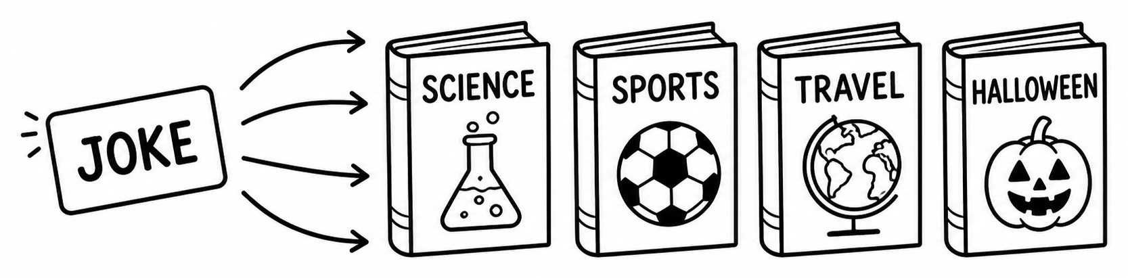

JOKE BOOK READING ADVENTURE
INSTRUCTIONAL GUIDE
Which Joke Doesn’t Belong?
JBRA-T08 COMPANION STUDENT ACTIVITY JBRA-S08

READING FOCUS
Comparing and Categorizing
LEARNING OBJECTIVE
Students will compare groups of jokes and determine which one does not belong with the others. They will learn that good readers compare details, recognize patterns, and support their decisions with evidence. This same skill strengthens comprehension in fiction, nonfiction, and informational reading.
MATERIALS NEEDED
- JBRA-S08 Student Activity Sheet
- Pencil or pen
- Optional: one or more illustrated or themed joke books
BEFORE STUDENTS BEGIN
Ask: “If I showed you four pictures of animals—a lion, a tiger, a leopard, and a dolphin—which one wouldn’t belong?” After students answer, ask, “Why?” Explain that good readers don’t just find the answer—they explain their thinking. Today’s activity asks students to compare several jokes, identify the one that doesn’t fit the group, and explain why.
QUICK COMPARISON EXAMPLES
Use one or two of these examples before beginning the activity.
1. Seasons: Display these words: Snowman • Santa • Reindeer • Beach Ball. Ask which one doesn’t belong and what clues helped. Discuss how Beach Ball belongs to a different season.
2. Transportation: Display: Train • Airplane • Bicycle • Banana. Ask which one doesn’t belong and whether someone could make a different argument. Readers should support answers with evidence.
3. Joke Themes (if space allows): Show Science • Sports • Halloween • Vegetables. Ask which one doesn’t belong and why. More than one answer may be reasonable when students explain their thinking clearly.
TEACHING TIPS
Encourage students to explain their thinking before revealing an answer. Ask:
- Which clues did you notice first?
- What do the other three have in common?
- Could someone reasonably choose a different answer?
- Which explanation is supported by the strongest evidence?
WHY THIS ACTIVITY WORKS
Comparing and categorizing are essential reading skills. Readers naturally group ideas, notice similarities and differences, and decide what belongs together. This activity develops flexible thinking by encouraging students to justify decisions with evidence instead of simply choosing an answer.

DISCUSSION QUESTIONS
- Which group was the easiest to compare? Why?
- Did anyone choose a different answer and still make a good case?
- What clues helped you decide?
- Why is it important to explain your thinking?
EXTENSION ACTIVITIES
- Create four new categories and challenge classmates to identify the item that doesn’t belong.
- Ask students to create a set in which more than one answer could be defended.
- Have students explain their reasoning orally before writing it down.
DIFFERENTIATE THE LESSON
Support: Begin with obvious categories before introducing more challenging comparisons.
Challenge: Invite students to defend two different answers using evidence and compare which explanation is stronger.
CROSS-CURRICULAR CONNECTIONS
Language Arts • Science (classification) • Mathematics (sorting and patterns) • Social Studies • Fiction and Nonfiction Reading
RECOMMENDED JOKE BOOKS
Using several themed joke books together works especially well because students naturally compare topics and look for similarities and differences. Themes might include sports, math, science, or holidays—whatever is available in the classroom, library, or at home. Illustrated joke books provide additional clues that support students’ reasoning.
TEACHING TIP
When students disagree, avoid saying, “That’s wrong.” Instead ask, “Can you support your answer with evidence?” That simple question encourages deeper thinking and richer classroom discussions.
BEYOND JOKE BOOKS
Readers compare information constantly: characters, settings, historical events, scientific observations, mathematical patterns, and authors’ ideas. Encouraging students to explain why something belongs—or doesn’t belong—helps them become thoughtful readers across every subject area.

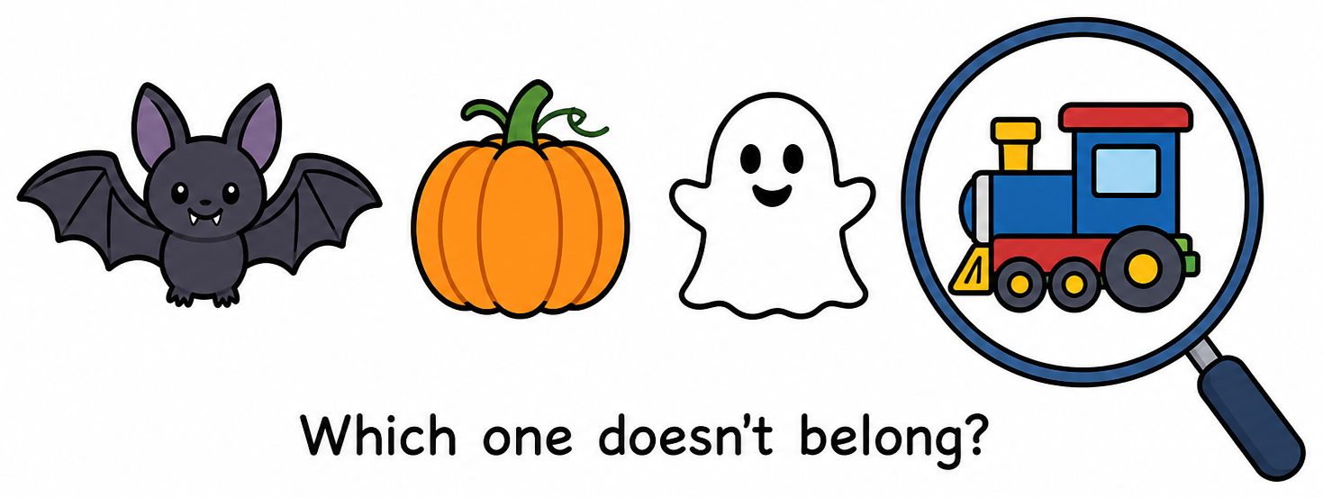

JOKE BOOK READING ADVENTURE
INSTRUCTIONAL GUIDE
Picture It!
JBRA-T09 COMPANION STUDENT ACTIVITY JBRA-S09

READING FOCUS
Visualization
LEARNING OBJECTIVE
Students will create mental images from the words and details in a joke. They will learn that good readers picture characters, actions, settings, and objects as they read. Visualization supports comprehension, recall, prediction, and enjoyment across fiction, nonfiction, and informational reading. It is especially helpful for visual learners.
MATERIALS NEEDED
- JBRA-S09 Student Activity Sheet and pencil or pen
- Optional: crayons, colored pencils, or markers
- Optional: one or more illustrated joke books
BEFORE STUDENTS BEGIN
Ask: “Have you ever read something and seen the action happening like a movie in your mind?” Explain that readers often create pictures in their minds from an author’s words. These mental images help readers understand and remember what they read. People may imagine the same words differently. A visualization does not need to match someone else’s picture exactly; it should be supported by details in the text.
QUICK VISUALIZATION EXAMPLES
Use one or two examples before beginning the activity.
1. A Silly Scene: Read, “A penguin wearing sunglasses carried an umbrella across the beach.” Ask what students pictured first, which colors they imagined, where the penguin stood, and whether anyone pictured the scene differently. The sentence supplies some details; readers supply others.
2. Picture the Punch Line: Read, “Why did the banana go to the doctor? Because it wasn’t peeling well!” Ask students to picture the banana’s expression and the doctor’s office. How does the mental picture make the joke funnier?
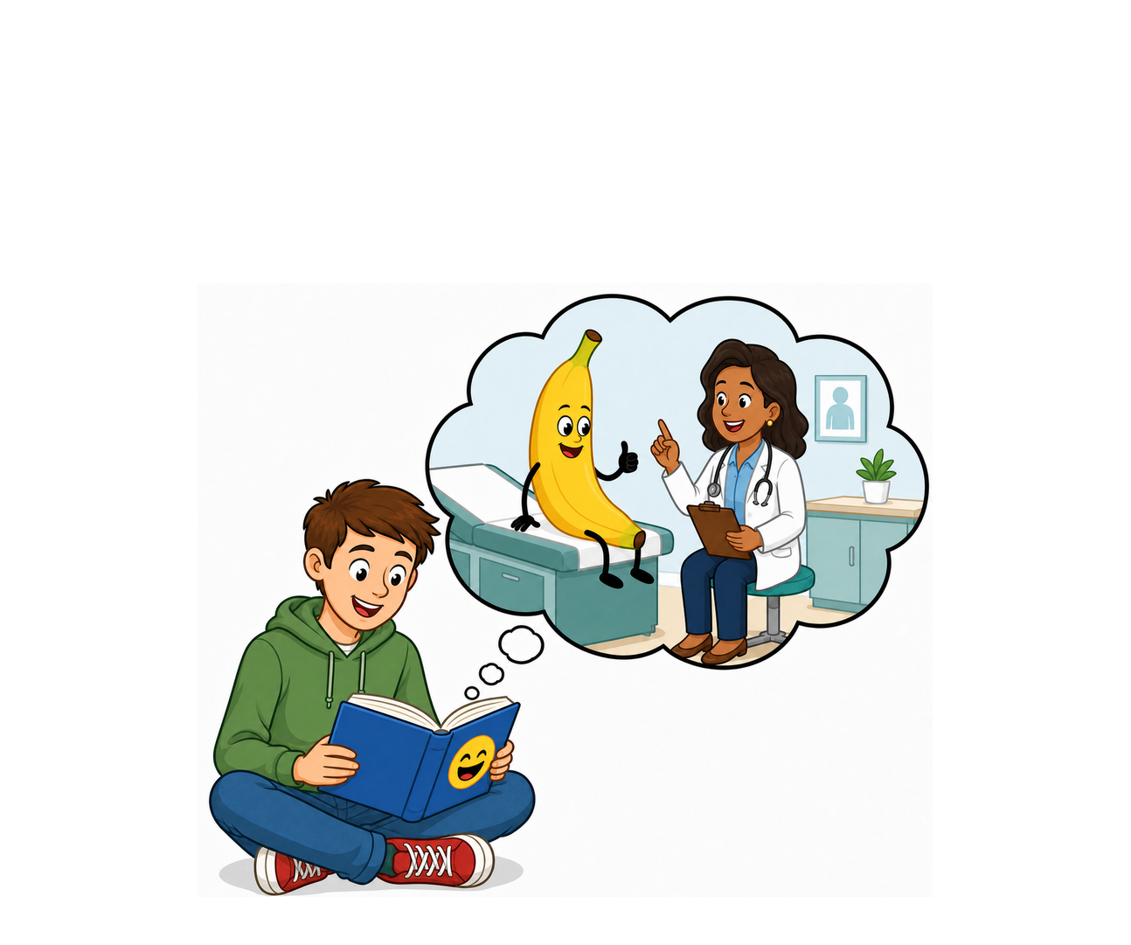
3. Add Details (if space allows): Display: A ghost reading a joke book in a library. Ask students to describe the setting, the ghost’s expression, and other details that make the scene interesting.
TEACHING TIPS
Before students draw, invite them to close their eyes briefly and picture the joke. Ask:
- Who or what do you see, and where is the action happening?
- What is the character doing?
- Which words helped create your picture?
- Does the punch line change what you imagine?

WHY THIS ACTIVITY WORKS
Visualization turns reading into an active experience. When students create mental images, they connect words with characters, actions, settings, and prior knowledge. These connections strengthen comprehension and help students remember what they read.
DISCUSSION QUESTIONS
- Which joke was easiest to picture? Why?
- Which words created the clearest image?
- Did your picture change after you read the punch line?
- How were classmates’ pictures different, and how did visualization help you understand the joke?
EXTENSION ACTIVITIES
- Read a joke aloud without showing its illustration. Have students draw what they pictured, then compare with the book’s illustration.
- Add sensory details by describing what students might see, hear, smell, feel, or taste.
- Write a joke that creates a strong mental image, or compare two illustrations made for the same joke.
DIFFERENTIATE THE LESSON
Support: Read one joke aloud and guide students to identify the character, action, setting, and important details before drawing.
Challenge: Ask students which words influenced specific parts of their picture and which details came from their imaginations.
CROSS-CURRICULAR CONNECTIONS
Language Arts • Art • Creative Writing • Science Observation • Speaking and Listening • Fiction and Nonfiction Reading
RECOMMENDED JOKE BOOKS
Illustrated joke books work especially well. Cover the illustration while students listen to or read the joke. After they create their own pictures, reveal the published illustration and compare interpretations. Books with vivid characters, settings, and actions provide especially strong opportunities for visualization.
TEACHING TIP
Avoid treating the published illustration as the one “correct” picture. Ask which details came directly from the words and which details each illustrator imagined. This helps students distinguish textual evidence from creative interpretation.
BEYOND JOKE BOOKS
Readers visualize characters in novels, processes in science, places in social studies, and situations in math problems. Pausing to picture what they read can improve understanding across every subject.

JOKE BOOK READING ADVENTURE
INSTRUCTIONAL GUIDE
Solve the Joke!
JBRA-T10 COMPANION STUDENT ACTIVITY JBRA-S10

READING FOCUS
Using Everything You’ve Learned
LEARNING OBJECTIVE
Students will independently select and apply the reading strategies practiced throughout the Joke Book Reading Adventure. They will use context clues, wordplay, visual details, prior knowledge, categorization, visualization, and other comprehension strategies to understand and explain unfamiliar jokes.
MATERIALS NEEDED
- JBRA-S10 Student Activity Sheet and pencil or pen
- Optional: one or more illustrated or themed joke books
- Optional: completed activity sheets from earlier lessons
BEFORE STUDENTS BEGIN
Ask: “What does a good detective do when the answer is not immediately obvious?” Discuss looking for clues, examining details, considering possibilities, and checking whether an answer makes sense. Explain that good readers do the same. Today students become Joke Detectives who choose the right tools to solve jokes independently.
QUICK SOLVE-IT EXAMPLES
Joke Detective Toolkit: Use context and hidden clues; notice multiple meanings and sound-alike words; study illustrations; connect prior knowledge; recognize categories; compare details; visualize; reread; and test whether an explanation makes sense. A joke may require more than one strategy.
1. Wordplay: “Why was the math book sad? Because it had too many problems.” Ask which word is the key clue, what its two meanings are, and which strategy solved the joke.
2. Prior Knowledge and Visualization: “Why did the bicycle fall over? Because it was two-tired!” Ask what students need to know about bicycles, which words sound alike, what they picture, and whether they used more than one strategy.
3. Visual Clue (if space allows): Show a joke whose illustration reveals an important detail. Ask what the picture adds, whether the joke would be harder without it, and which other strategy helped.
TEACHING TIPS
When students become stuck, avoid immediately explaining the joke. Ask:
- What do you notice, and which word or picture might be a clue?
- Does a word have two meanings or sound like another word?
- What do you already know, and can you picture what is happening?
- Which strategy have you not tried yet?

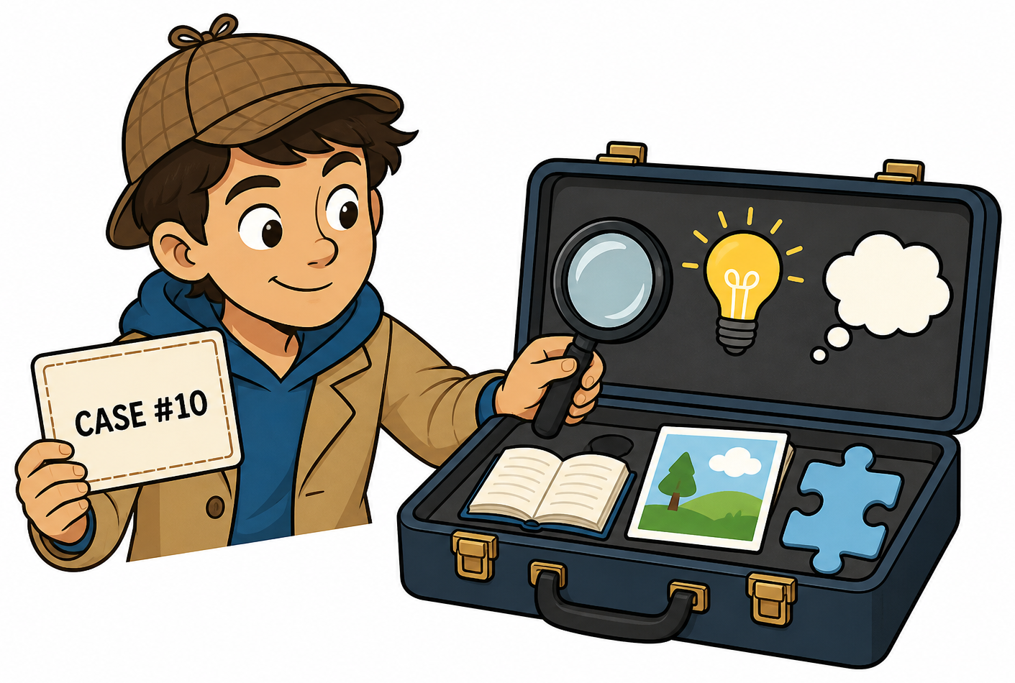
- WHY THIS ACTIVITY WORKS
Strong readers choose strategies flexibly. They notice when meaning breaks down, select an appropriate tool, and check whether their interpretation makes sense. This activity combines individual skills into an independent comprehension process.
DISCUSSION QUESTIONS
- Which strategy did you use most often?
- Which joke required more than one strategy?
- Which clue was easiest to miss?
- What did you do when your first explanation did not make sense, and which strategy will help outside joke books?
EXTENSION ACTIVITIES
- Create a joke and identify the strategies a reader would need to understand it.
- Exchange jokes with a partner and explain the thinking step by step.
- Create a Joke Detective Challenge, or revise a confusing joke by adding a useful word or visual clue.
DIFFERENTIATE THE LESSON
Support: Provide a visible checklist of Joke Detective strategies and help students choose one tool at a time.
Challenge: Solve a joke in more than one way, name every strategy used, and identify the clue with the strongest evidence.
CROSS-CURRICULAR CONNECTIONS
Language Arts • Critical Thinking • Problem-Solving • Speaking and Listening • Art • Mathematics • Science • Social Studies
RECOMMENDED JOKE BOOKS
Use varied joke books so students encounter different topics, formats, vocabulary, illustrations, and types of humor. A mixture of illustrated, themed, and general books encourages students to select strategies instead of relying on the same clue every time. Initially confusing jokes are especially useful because students must reread, investigate, and test explanations.
TEACHING TIP
Celebrate the reasoning process, not just the correct explanation. A student who tries several strategies, revises an idea, and supports a conclusion with evidence is demonstrating exactly what capable readers do.
BEYOND JOKE BOOKS
Readers combine strategies whenever they encounter difficult text. They examine vocabulary, study illustrations and text features, connect prior knowledge, visualize, compare details, and reread when meaning breaks down. Choosing and combining these tools helps students become confident, independent readers.

JOKE BOOK READING ADVENTURE
INSTRUCTIONAL GUIDE
Keep the Reading Adventure Going!
JBRA CLOSING ACTIVITY • COMPANION STUDENT PAGE: KEEP READING!
🎯 PURPOSE  Help students recognize how much they have learned, celebrate their growth as readers, and make a personal plan to continue reading, collecting, and sharing jokes.  🧰 MATERIALS NEEDED  • Completed student activity guide  • Pencil or pen  🚦 BEFORE STUDENTS BEGIN  Direct students to the “Keep Reading!” page at the end of their activity guide. Remind them that they have practiced strategies strong readers use with every kind of text—not only joke books.  Read the strategy list together. Invite students to place a small star beside two strategies they feel especially confident using.  🌟 CELEBRATE THEIR READING GROWTH  Use one or more prompts for a brief class discussion:  • Which reading strategy helped you understand jokes the most?  • Which activity made you think in a new way?  • What did you learn about how jokes work?  • Which strategy will help you when you read other kinds of books?  Reinforce that jokes may be short, but understanding them can require prediction, visualization, background knowledge, attention to details, inference, and flexible thinking.  😂 KEEP THE LAUGHTER GOING  Give students time to explore the Ralph Lane joke books on the closing page and record choices in “Joke Books I’d Like to Read.” Then have them write a favorite school-appropriate joke in “My Favorite Jokes.”  If time permits, invite volunteers to share a joke. Ask listeners to identify one reading strategy that helped them understand the punchline.  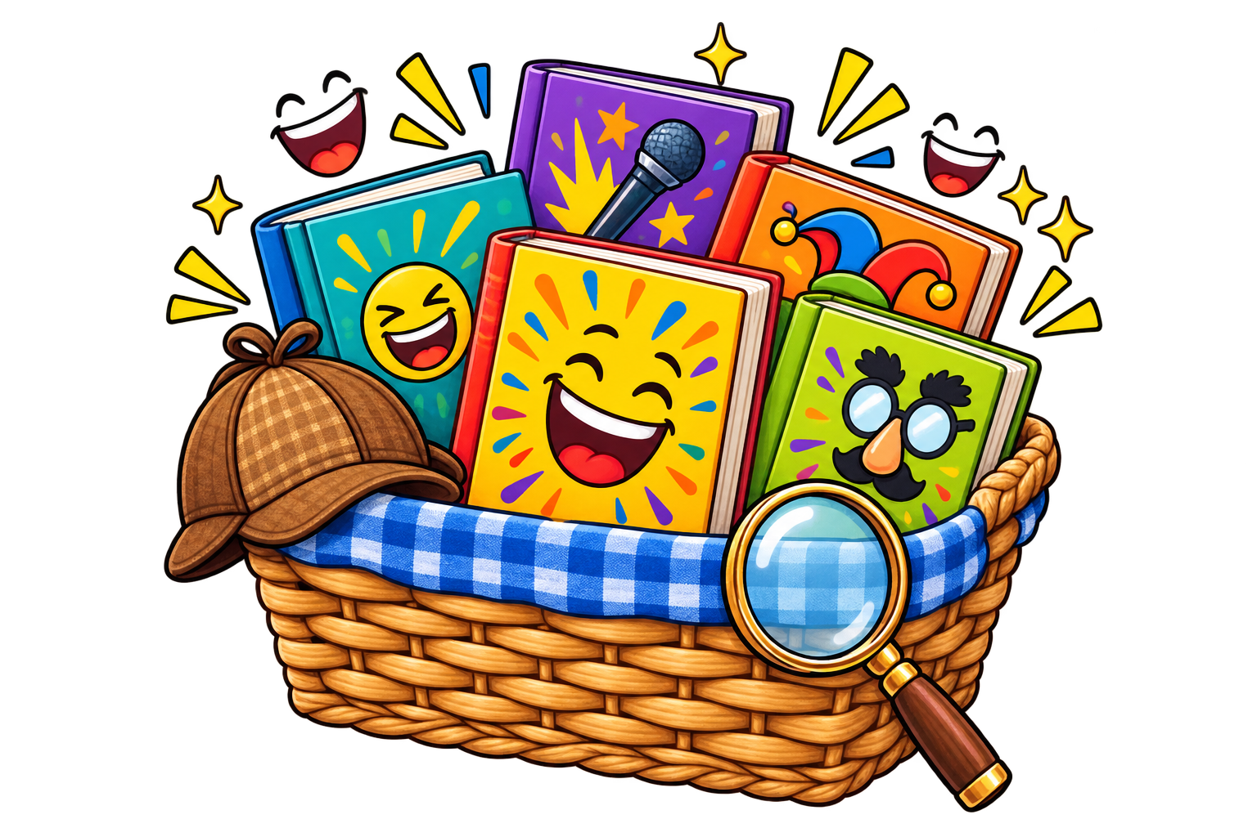 | 🚀 EXTEND THE ADVENTURE  • Create a rotating joke-book basket or classroom display.  • Check with your school librarian or local library to see if they carry joke books students could access.  • Begin selected days with a “Joke of the Day.”  • Let students recommend joke books to classmates.  • Invite students to collect favorite jokes in a reading notebook.  • Pair joke books with classroom topics, seasons, holidays, or student interests.  • Occasionally ask students to explain the clues, wordplay, or background knowledge behind a punchline.  💡 TEACHER NOTE  🧠 A SMALL TEXT—BIG THINKING  🔎 A FINAL MESSAGE FOR YOUR JOKE DETECTIVES  Celebrate students for completing the Joke Book Reading Adventure. Remind them that strong readers do not always understand everything immediately. They stay curious, look for clues, try different strategies, and keep reading.  Keep reading. Keep thinking. Keep laughing!
  Joke books can be especially inviting for reluctant or developing readers. Their short selections offer frequent success, while punchlines reward careful reading and rereading. Sharing jokes also gives students an authentic reason to read fluently and with expression.
  Understanding a joke is a surprisingly sophisticated act of reading. A reader may need to make an inference, recognize ambiguity, retrieve background knowledge, notice an incongruity, and reinterpret what came before—all in a sentence or two.
  Jokes are miniature exercises in reading comprehension.

